Shared Use of Poles Code

Version Control

Version | Date | Amendment | Distribution Company | Representative
0.1 | 13/05/2014 | Issued for industry comments | Jemena | Oliver Jones/Max Demko
 |  |  | CitiPower | Ian Luscombe/Luke Farrugia/Anwar Qayyum
 |  |  | Powercor | Ian Luscombe/Luke Farrugia/Anwar Qayyum
 |  |  | SPAusNet | Saman DeSilva
 |  |  | United Energy Distribution | Jim Tsirikis

Table of Contents

1 Version Control 2
2 Preamble 4
3 Interpretation 4
4 Disclaimer 5
5 Amendments to the Code 5
6 Scope 5
7 How to Use This Document 6
8 Definitions 6
9 General Requirements for Shared Use of Poles 9
9.1 Agreements 9
9.2 Applications 9
9.3 Fees 10
9.4 Permits and Standards 10
9.5 Poles Unsuitable for Shared Use 11
9.6 Limited life and staked poles 11
9.7 Clearances 11
9.8 Method of Attachment of Shared Users Equipment 12
9.9 Maintenance, Removal, Disconnection and Ownership of Shared User’s Equipment 12
9.10 Effect on Electricity Distribution System 13
10 Calculations 14
11 Training and Competence, Auditing & Record Keeping 14
11.1 Shared User Training 14
11.2 Auditing 14
11.3 Record Keeping 15
12 Electricity Supply 15
13 Operation of the Electrical Distribution System 15
14 Information – Shared User Types 15
14.1 Aerial Cabling & Equipment 15
14.2 Radio Frequency Telephone Equipment (Antennae) 27
14.3 Signs and Other Minor Attachments on Poles 35
14.4 Flags, Banners and other Decorations (or Higher Up) Attachments on Poles 41
14.5 Distribution Business Boundaries 45
14.6 Distribution Business Fault and Emergency Contacts 46
14.7 Appendices 47

Preamble
This Shared Use of Poles Code ("Code"), which supersedes the “Code of Engineering Practice for Shared Use of Poles” (dated 27 February 1996), has been prepared and approved by the Victorian Electricity Distribution Companies ("Distribution Companies") which applies to all new Shared Use installations including All-Dielectric Fibre Optic Cables, Antennae, Signs and Banners.

For technical aspects in relation to the maintenance and/or extension of existing PSTN, Co-Axial Cable, Catenary Strung Cable systems refer to the Code of Engineering Practice for Shared Use of Poles 1996. Notwithstanding this, clearances as specified in the new Code will apply to all new Shared Use attachment.

Amongst other things, this Code sets out:

- The requirements for the design, construction, attachment, safety, operation, maintenance and removal of Shared User's Equipment Attached to a Distribution Company owned Pole;

Before Shared User's Equipment is attached to a Pole a Shared User must enter into an Agreement with the relevant Distribution Company and where required, submit and have approved an Application for Shared Use by the relevant Distribution Company (Applications requirements are incorporated within an Agreement).

The format and content of an Agreement depends on the type of Shared Use being employed, however, all Agreements will include the commercial and legal aspects of the Shared Use.

Where an Agreement includes requirements which are additional to or exceed those in this Code, then the requirements of the Agreement shall prevail.

Interpretation
In this Code, unless the context requires otherwise:

- The singular includes the plural and vice versa;
- A gender includes the other genders;
- The index (if any) and the headings are used for convenience only and do not affect the interpretation of this Code;
- A reference to a thing includes a reference to a part of that thing;
- A reference to a document includes the document as modified from time to time and any document replacing it;
- If something is to be done on a day which is not a Business Day then that thing must be done on the next or following Business Day;
- The word "person" includes a natural person and any body or entity whether incorporated or not;
- The word "month" means calendar month and the word "year" means twelve months;
- The words "in writing" include any communication sent by letter, email or facsimile transmission;
- A reference to any statute, proclamation, rule, regulation or ordinance includes any amendment, consolidation, modification, re-enactment or reprint of it or any statute, proclamation, rule, regulation or ordinance replacing it. A reference to a specified section, clause, paragraph, schedule or item of any statute, proclamation, rule, regulation or ordinance means a reference to the equivalent section of the statute, proclamation, rule, regulation or ordinance which is for the time being in force;
- Wherever "include" or any form of that word is used it must be construed as if it were followed by "(without being limited to)"; and
- A reference to any agency or body, if that agency or body ceases to exist or is reconstituted renamed or replaced or has its powers or functions removed ("defunct body"), means the agency or body which performs most closely the functions of the defunct body.

Disclaimer
The Distribution Company, in preparing and making available this Code, makes no representations or warranties in relation to the information, recommendations, or standards set out in this Code. Any person wishing to use this Code should, before such use, independently assess the commercial, technical and safety ramifications of the information and standards contained in this Code and act in reliance on its own assessment.

Amendments to the Code
Amendments to this Code may be made from time to time by the Code Committee.

When this Code is amended, the Amendment Date will be inserted on the bottom right hand corner of each page of this Code and the Shared User will be able to obtain a new copy of the Code by accessing the Shared Use of Poles Code located on the VESI web site (www.vesi.com.au).

Unless otherwise agreed in writing by the Parties, amendments made to this Code will be effective from the Amendment Date.

Where the amendment relates to:

- Issues of health and safety; or
- Issues which affect the operation or performance of the Electricity Distribution System,

The Code Committee may specify that compliance with the amendment applies to existing Attached Shared User's Equipment.

This document is copyright. Except as permitted under the Copyright Act 1968 (Cth), no part of this publication may be reproduced by any process, electronic or otherwise, without the specific written permission of the copyright owner. Neither may information be stored electronically in any form whatsoever without such permission.

© 2013
CitiPower Pty ABN 76 064 651 056 of 40 Market Street, Melbourne, Victoria, 3000;
SP Australia Networks (Distribution) Ltd ABN 37 108 788 245,Level 31, 2 Southbank Boulevard Southbank, Victoria 3006;
Powercor Australia Ltd ABN 89 064 651 109 of 40 Market Street, Melbourne, Victoria, 3000;
Jemena Electricity Networks (VIC) Ltd ABN 82 064 651 083, 321 Ferntree Gully Rd, Mount Waverley, Victoria, 3149; and
United Energy Distribution Pty Ltd ABN 70 064 651 029 of 43-45 Centreway Place Mount Waverley 3149.

Inquiries shall be addressed to the Distribution Company within whose area Shared Use is required (Refer Clause 14.5 - Distribution Business Boundaries).

Scope
This Code sets out the minimum requirements which apply to the attachment by a Shared User of its equipment on a Distribution Company’s power or public lighting poles. In setting out these requirements the Code provides support to any Agreement established between a Distribution Company and a Shared User.

Any Agreement established between a Distribution Company and a Shared User may include additional requirements.

This Code does not provide information on the provision of an electricity supply for Shared User’s Equipment. For information on electricity supplies reference should be made to the Victorian Service and Installation Rules (SIR).

This Code applies to the attachment of Shared Use equipment such as, but not limited to:

- Cables, wires and leads;
- Power supplies, control boxes, switch boxes, terminal boxes and fuse boxes;
- Telecommunication Antennae, communications dishes and any associated equipment (i.e. cables, terminal boxes etc.);
- Electrolysis equipment; and
- Minor hardware such as signs, flags, banners, Christmas/event decorations, and traffic signals or any other minor attachments approved by the Distribution Company.

This Code is not normally intended to be retrospectively applied where compliance to the previous Code was met at the time of installation. Any alteration of, or modification to an existing Shared Users attachment shall be deemed to be a new Shared User attachment, and all relevant provisions of this Code shall apply to every such alteration or amendment.

How to Use This Document
This Code has been prepared to enable a Shared User to read only those sections relevant to the type of Shared Use Equipment proposed to be attached to a Pole.

Clauses1 to 13 of this Code apply to all Shared Users Equipment and all attachments must comply with these clauses.

Clause 14applies to specific types of Shared Users Equipment. Shared Users are only required to comply with the sub-clause of the Code that is relevant to the type Shared Use Equipment they propose to attach to the pole.

Example: A Shared User proposing to attach a Telecommunication Antennae is required to comply with Clauses 1 to 13 and Clause 14.2 Radio Frequency Telephone Equipment (Antennae) within the Code.

Definitions
In this Code, unless the context requires otherwise or otherwise agreed by the Parties:

  - "ABC" has the same meaning as "Aerial Bundled Cable";
  - “Aerial Bundled Cable" means the Distribution Company's HV or LV insulated aerial bundled cables;
  - "Aerial Cable" means a Catenary, wire, cable, or other form of tension member which is Attached to a Pole aerially, but does not include Aerial Customer Lead, PSTN cable, VicTrack's Electrical Conductor or Electrolysis Drainage Cable;
  - "Aerial Customer Lead" means the Customer Lead aerially connected;
  - “Agreement” means any written agreement (e.g. facility access agreement or license agreement) entered into by the Parties which allows Shared Use of a Pole subject to an Application being approved by the Distribution Company;
  - "Amendment Date" means the date on which this Code is amended in accordance with clause 5;
  - "Application" means a written document submitted by a Shared User which seeks approval for each proposed attachment to a Pole in accordance with the requirements of an Agreement. The Application contains information which the Distribution Company requires so that it can assess the acceptability of the Shared Use. Typical information that may be required is shown in Appendix A);
  - “Antenna” means any system of wires, poles, rods, aerials, reflecting discs, or similar devices used for the transmission or reception of electromagnetic signals;
  - "Attach" means to attach, connect, bond, install, or support and "Attachment" and "Attached" have a corresponding meaning;
  - “ACIF” means the Australian Communications Industry Forum, established to develop and administer communications industry technical and operational arrangements;
  - “Business Day” means a day which is not a Saturday, Sunday, a public holiday (for the whole day) or a bank holiday (for the whole day) in the State of Victoria;
  - "Calculation" means the calculations which are required to be carried out in accordance with this Code including without limitation the calculations required to determine the mechanical loads which are applied to a Pole by Shared User's Equipment;
  - "Catenary" means a separately constructed strength member Attached to Poles to which Shared User's Equipment is or may subsequently be attached including that part of an integral bearer cable which is used to support wires and cables and which is enclosed in a cover or a sheath. Catenaries are usually metallic, non-insulated and installed continuously over a number of consecutive spans. They do not form part of any telecommunications circuit;
  - "CMEN" means an Electrical Distribution System's earthing system where all HV and LV equipment within an area is connected to a common earth.
    - In a CMEN system of earthing, the LV neutral conductor is permanently connected to earth at:
      - Each of the multiple distribution substations supplying the Electrical Distribution System;
      - All customer's premises, in accordance with the Electricity Safety (Installations) Regulations 2009 (S.R. No. 164/2009) and AS/NZS 3000; and
      - Other points throughout the neutral system, as required;
      - Thus forming a CMEN conductor which has an impedance to ground of less than 1 ohm within the CMEN area;
  - "Code" means this document entitled "Shared Use of Poles Code" including the preamble, scope and appendices;
  - "Code Committee" means a committee consisting of representatives of the Distribution Companies;
  - “Communication Equipment” means a cable network system belonging to a telecommunications company which includes, but not limited to, Communication Lines, Customer Leads, Electrical Equipment, housings, junction boxes, conduits used for the provision of telecommunication services;
  - “Communications Line” means a wire or cable which can include strength bearer, catenary, joint closures, optical fibres, supports and fittings owned by the Shared User which accommodates telecommunication services, but excluding Customer Lead. Where a Communication Line is insulated it must be wholly covered with insulating material in accordance with the relevant Australian Standard or equivalent;
  - "Customer Lead" means a lead connecting the Shared User's cable network to the customer's premises where the relevant connection is located on a Catenary at least 1 metre away from the point at which the Catenary is Attached to the Pole but no greater than 2 metres*;
    - *As of the date of the amendment of this Code, with the exception of PSTN, new Fly-Off Points at the Pole and within 1 metre of the pole are not permitted;
  - “Data” means the information, including but not limited to survey results, G.I.S. queries, obtained by the Shared User with regards to the particular Pole(s) the Shared User wishes to Attach to.
  - "Distribution Company" means the electricity distribution company (i.e. CitiPower Pty, SPI Network Pty Ltd, Powercor Australia Ltd, Jemena Electricity Networks (Vic) Ltd and United Energy Distribution Pty Ltd) which owns the Pole that is subject to an Application;
  - “Energy Safe Victoria” means the government body responsible for energy safety and equipment efficiency in Victoria and was formally known as the “Office of the Chief Electrical Inspector";
  - "Electricity Distribution System" means the Distribution Company's electricity distribution and subtransmission systems and all equipment forming part of those systems;
  - "Electrolysis Drainage Cable" means the electrolysis mitigation system managed by the Victorian Electrolysis Committee;
  - "Emergency" means an emergency due to the actual or imminent occurrence of an event which in any way endangers or threatens to endanger the safety or health of any person or which destroys or damages, or threatens to destroy or damage, any property including, but not limited to:
    - an earthquake, flood, wind-storm or other natural event;
    - a fire;
    - an explosion;
    - a road accident or any other accident;
    - a warlike act, whether directed at Victoria or a part of Victoria or at any other State or Territory of the Commonwealth; and
    - a hi-jack, terrorist act, siege or riot;
  - “Elevating Work Platform” means a telescopic device, scissor device, or articulated device, or any combination thereof used to position personnel, equipment and materials at work locations above or below the base support surface;
  - “ESV” has same meaning as “Energy Safe Victoria” and was formally known as the “OCEI”;
  - “EWP” has the same meaning as “Elevating Work Platform";
  - “Fibre Optic Cable” means a cable which is made up of thin strands of glass, along which light signals can pass to provide communication;
  - "Fly-Off Point" means the point at which an Aerial Customer Lead is Attached to a Catenary at a distance of between 1 metre and 2 metres from the Pole*;
    - *(As of the date of the amendment of this Code, with the exception of PSTN, new Fly-Off Points at the Pole and within 1 metre of the pole are not permitted);
  - “FOLCB” means Fused Overhead Line Connection Box.
  - “FSD” means Fuse Switch Disconnector.
  - “GIS” means Geographical Information System.
  - "High Voltage" means r.m.s. power frequency voltages in excess of 1kV;
  - "HV" has the same meaning as "High Voltage";
  - "HV ABC" means the Distribution Company's High Voltage, 3 phase, insulated Aerial Bundled Cable, complete with bare support conductor;
  - "Joint Use" means the use of a Pole in accordance with the Joint Use of Poles Arrangement;
  - "Joint Use of Poles” means the Joint Use of Poles Arrangement between the Electricity Supply Association of Australia and Telstra. Refer Joint Use of Poles document – The placement on poles of power lines and paired cable telecommunications lines (CJC 1 – 1997, SAA HB87-1997);
  - "Limited Life Pole" means a Pole that when inspected by the Distribution Company in accordance with its standard procedures is considered serviceable but because of its condition may not remain serviceable until the next programmed inspection and therefore will be inspected more frequently;
  - "Low Voltage" means r.m.s. power frequency voltages up to and including 1kV;
  - “LV" has the same meaning as "Low Voltage";
  - "LV ABC" means the Distribution Company's Low Voltage, insulated Aerial Bundled Cable;
  - “LV Service” means the final span or section of a low voltage aerial line that is part of the supply network connected to a customer premises.
  - "Make Ready Works" means that work which is necessary to be carried out prior to or at the time when Shared User's Equipment is Attached to a Pole in order to make the Pole suitable for Attachment of Shared User's Equipment but does not include the replacement or maintenance of the Electricity Distribution System which has become unserviceable or obsolete, or any work that may be required for reasons other than to make the Pole suitable for Attachment;
  - "Parties" means the Distribution Company and the Shared User and "Party" means any one or both of the Parties as the context requires;
  - "Pole" means a pole including crossarms, raisers, brackets and other fittings owned and installed by the Distribution Company to support its Electricity Distribution System;
  - “Pole Identification Number” means a number or combination of numbers and letters that are used as part of an identification system by a Distribution Company to uniquely identify individual poles;
  - "PSTN" means Public Switched Telephone Network and is that part of the public telecommunications network which enables any customer to call and communicate with any other customer either automatically or with operator assistance;
  - "Public Lighting Pole" means a Distribution Company's pole, which is specifically designed for public lighting and may or may not have Shared User's Equipment Attached;
  - "Shared Use" means where the Shared User has or does Attach Shared User's Equipment;
  - "Shared User" means a party who intends to or is using a Pole in accordance with this Code and an Agreement;
  - "Shared User's Equipment" means all items of equipment owned or operated by the Shared User that are Attached or are proposed to be Attached or at some stage have been Attached to a Pole;
  - "Staked Pole" means a wooden Pole that is reinforced in accordance with the Distribution Company's standard procedures for Pole reinforcement;
  - "Stayed Pole" means a Pole which is supported in one or more directions by an aerial stay or a ground stay or both;
  - "Strained Configuration" means the Attachment of an Aerial Cable or PSTN cable to a Pole where the Attachment and any related fittings are specifically designed to support the tension of the Aerial Cable, PSTN cable, VicTrack's Electrical Conductor or Electrolysis Drainage Cable.
  - “Victorian Rail Track” means a corporation established under Section 8 of the Rail Corporations Act 1996 (as in force immediately before the commencement of the Transport Integration Act 2010 and the corporation continues under Section 116 of this later Act.
  - "VicTrack" is a trading name that may be used by Victorian Rail Track for the purpose of carrying on business;

General Requirements for Shared Use of Poles

Agreements

Before Shared User’s Equipment is attached to a Pole a Shared User must enter into an Agreement with the relevant Distribution Company.

The format and content of an Agreement depends on the type of Shared Use being employed.

Applications

Unless otherwise agreed in writing by the Parties, a Shared User who proposes to Attach Shared User's Equipment to a Pole must in addition to having an Agreement, submit an Application to the Distribution Company.

An Application form, or the information required, to complete an Application relevant to the type of Shared Use, is available from the Distribution Company.

As a minimum, the Shared User must identify in the Application all information that allows the Distribution Company to appropriately assess an application. This may include items below:

- The Pole(s) to which it proposes to Attach Shared User's Equipment by quoting its unique Pole Identification Number used by the Distribution Company or other agreed method of identification;
- The type of Shared User’s Equipment it proposes to attach;
  - Dimension drawings, photographs and manufacturer's drawings;
  - All relevant test results regarding the suitability of the Shared User's Equipment and method of Attachment;
  - Aspects of the Shared User's Equipment or method of Attachment that will impact on the appearance, safety, operation, maintenance or performance of the Electricity Distribution System including, but not limited to, size, colour, weight, material type, safe distances of approach where equipment emits radiation, levels of radiation from equipment, zone of radiation of equipment, operating voltage, power consumption and any applicable mechanical strengths such as, but not limited to tensile strength of a cable and minimum failing load of brackets; and
  - Confirmation of compliance with all relevant legislation and the requirements of this Code.

(Reference should be made to Clause 14.5 for geographical areas covered by the Distribution Companies).

Fees

Fees will be detailed in the Agreement with the Distribution Company. Typical fees may include but not limited to:

- Processing the Application;
- Make Ready Works;
- Auditing activities associated with the Shared Use;
- Shared Use of the Pole; or
- The provision of information, services or advice.

Permits and Standards

Permits

Unless otherwise agreed in writing by the Parties, the Shared User must, at the cost of the Shared User, obtain all necessary authorisations, licenses, permits and other requirements as required by law or otherwise to enable the Shared User to Attach, operate and maintain the Shared User's Equipment.

Standards

In respect of the Attachment, operation and maintenance of the Shared User's Equipment, the Shared User must at all times:

- Exercise due care and skill in accordance with good industry practice; and
- Unless otherwise agreed in writing, wherever it is applicable, comply with:
  - This Code;
  - An Agreement;
  - The Electricity Safety (Installations) Regulations 2009;
  - Vegetation clearances as specified in the Electricity Safety (Line Clearances) Regulations 2010;
  - Directions from Energy Safe Victoria (ESV) made within the scope of its functions and powers;
  - Any other statute, regulation ordinance or standard that is applicable to the Shared Users equipment; and
  - Any other statute, regulation, ordinance or standard that is from time to time amended and/or adopted by the Distribution Company and notified to the Shared User.

Poles Unsuitable for Shared Use

Due to operational and safety concerns the following types of poles are unsuitable for Shared Use at all times:

- Hinged public lighting poles;
- All types of frangible public lighting poles (except for minor signage as per Clause 14.3);
- 66kV cable head poles(cable termination poles);
- Unserviceable poles (This may include use of temporary stays)

In addition to the above the Shared User must refer to the relevant sub-clause of Clause 14 of this Code to determine which additional types of poles are considered unsuitable for their particular Shared Use.

Limited life and staked poles
- Limited Life Pole: Access by an EWP only. A connection can be made using a slack span or service drop. No need for pole replacement. Please note that the Pole condition need to be reassessed if the last inspection date is more than 12 months old.
- Staked Pole: Subject to loading assessments an attachment can be attached. Please note that Not all the Staked poles are restored to their original Strength.

Clearances

Asset Clearances of Shared Users Equipment

Clearances applicable to various types of Shared User’s Equipment are detailed in Clause 14 of this Code.

- It is the responsibility of the Shared User to ensure that the Attached Shared User's Equipment complies with the asset clearance requirements prescribed in this Code or in the Agreement related to the Shared Use.
- Where asset clearances in this Code are amended then it is the responsibility of the Shared User to ensure that the Shared User’s Equipment complies with the new asset clearances on an existing pole in the event that:
  - The Pole is replaced for whatever reason;
  - Major work is carried out on the Pole by the Shared User; and
  - The Distribution Company considers that the new clearances are necessary to achieve compliance with health and safety issues or provide improvement in the operation or performance of the Electricity Distribution System (Refer also to ‘Amendments to Code’ at the start of this document).
- Where an asset clearance for a particular situation is not included in this Code the Shared User shall seek approval by applying in writing to the relevant Distribution Company.

Clearances to Ground, Buildings, Structures and Vegetation

It is the responsibility of the Shared User to ensure that all required clearances between Shared User’s Equipment, the ground, buildings, structures and vegetation, comply with the asset clearance requirements prescribed in this Code or in the Agreement.

Clearance requirements to buildings and structures for Shared Users aerial cable networks are to be in accordance with ACIF C524:2013 – External Telecommunication Cable Networks.

Vegetation management (Tree Impact) requirements for Shared Users aerial cable networks are specified in ACIF C524:2013 – External Telecommunication Cable Networks.

Distribution Company to Direct

Unless otherwise agreed in writing by the Parties, if the Distribution Company determines that the Shared User's Equipment does not provide clearance in accordance with this Code, the relevant legislation or such other relevant document which prescribes specific clearances for specific types of Shared User's Equipment, it may (but is under no obligation to) direct the Shared User to take action to comply with the clearance requirements.

Method of Attachment of Shared Users Equipment

The Shared User must ensure that the Shared User’s Equipment is attached to a Pole using a method of Attachment so that:

- No screws or bolts or other construction materials penetrate the surface of any steel or concrete Pole;
- Metal or other strapping (e.g. Band-it) is not permitted on existing distribution cable head poles (cable termination poles).
- All strapping material is placed so that it is in direct contact with the Pole and must not be placed over any existing conduit, cable or wire;
- It does not interfere with or impair the access, use, function or operation of the Electricity Distribution System or any third party equipment;
- It is securely fixed to the Pole so that under high wind conditions it will not be dislodged or encroach within the clearances set out in this Code;
- It does not create or pose any risk to any persons as far as reasonably practicable;
- It can be removed by the Distribution Company where the Distribution Company determines that the removal of the Shared User’s Equipment is required;
- It will not enable a person to climb the Pole from ground level; and
- It will not damage Distribution Company equipment.

Maintenance, Removal, Disconnection and Ownership of Shared User’s Equipment

- The Shared User must ensure the Shared User's Equipment is properly maintained with respect to its condition, operation, security and method of Attachment;
- Unless otherwise agreed in writing by the Parties, except in the case of an Emergency (in which case clause 9.8.1 will apply), where the Distribution Company reasonably considers that the Shared User has not;
  - Correctly attached the Shared User's Equipment in accordance with clause 9.7; or
  - Has failed to provide for proper operation or maintenance of its Shared User's Equipment to an extent that the Shared User's Equipment has or may become a safety concern, or has or may affect the security of the Electricity Distribution System.
The Distribution Company may direct the Shared User to remedy the concern within a specified time.
- Unless otherwise agreed in writing by the Parties, in the event that a Shared Use Pole is no longer required by the Distribution Company (which includes but not limited to alterations to the Distribution Company’s network with respect to road management projects) or it becomes unsuitable for Shared Use, then the Distribution Company will advise the Shared User in writing that Shared Use is to be terminated
- In the event that termination of Shared Use of a Pole is required by the Distribution Company, it is not the responsibility or at the cost of the Distribution Company to provide an alternative means of support or location for the Attached Share User’s Equipment.
- Unless otherwise agreed in writing by the Parties, the Shared User will, at its own cost, remove Attached Shared User's Equipment upon termination of Shared Use agreement of a particular Pole, and where required, will repair, reinstate and/or rectify the Pole (to the requirements of the Distribution Company) to as far as reasonably possible the same condition as it was immediately before the Shared User's Equipment was Attached.
- Attached Shared User's Equipment always remains the property of the Shared User.

Emergency

- Unless otherwise agreed in writing by the Parties, in the case of an Emergency, the Distribution Company may adjust, remove or disconnect the Attached Shared User's Equipment as is reasonably necessary to remove or minimise the effects of a safety matter upon the Electricity Distribution System or any persons effected by the Emergency and the Distribution Company will, as soon as reasonably practicable thereafter, notify the Shared User of the action taken by the Distribution Company under this Clause 9.8.1.
- All reasonable costs of readjustment, installation or connection of the Shared User's Equipment after an Emergency shall be borne by the Shared User.

Persons, Mobile Plant or Vehicles

Unless otherwise agreed in writing, it is the responsibility of the Shared User to comply with all relevant legislation including the Blue Book in respect of works involving Distribution Company Assets where such works involve persons, mobile plant or vehicles.

The Shared User must ensure that when working on a Pole or in the vicinity of a Pole in respect of the Shared User’s Equipment, the Shared User must employ Safe Work Method Statements (SWMS) including, but not limited to:

- Where required, use only an insulated access platform of a type recognised as suitable for work near live electrical assets, and any access platform used must be accompanied by a current electrical test certificate;
- Ensure all personnel use appropriate and recognised Personal Protective Equipment (PPE);
- Have in place safe works procedures which as a minimum will:
  - Specifically relate to the tasks being undertaken; and
  - Be clearly readable and available on site at all times.

Effect on Electricity Distribution System

The Shared User agrees that notwithstanding that permission has been granted for Shared User's Equipment to be attached, the Shared User must ensure that the Shared User's Equipment does not damage, inhibit the operation or maintenance of the Electricity Distribution System or reduce its capacity, reliability or safety. Also the Shared User must ensure that the Shared User's Equipment does not damage, inhibit the operation or maintenance of any existing third party Shared User’s Equipment or reduce its capacity, reliability or safety.

Calculations

An Application is required to include Calculations and supporting Data as determined by the Distribution Company to ensure:

- The pole maximum allowable design load is not exceeded; and
- All clearances specified in this Code are achieved.

An Application will only be accepted by the Distribution Company where the results of the Calculations are acceptable to the Distribution Company.

Unless a Distribution Company has agreed in writing to carry out an assessment of the suitability or strength of a particular Pole (at the cost of the Shared User) and provided to the Shared User a written acknowledgment of the Pole's suitability or strength, the Distribution Company does not warrant the suitability or strength of any Pole for its proposed use.

Training and Competence, Auditing & Record Keeping

Shared User Training

The Shared user is responsible for maintaining training records associated with persons accessing Distribution Company assets. Such records may be audited by the Distribution Company.

Training and Qualifications

Shared Users shall refer to and comply with all requirements specified in the “Safety Compliance Training Requirements for Telecommunications Work on VESI Network Operator Assets”. Refer to the VESI website (www.vesi.com.au) for these requirements.

Shared Users shall refer to training courses recognised by the relevant Distribution Company for attachment of Signs, minor attachments and banners.

Auditing

Unless otherwise agreed, the Shared User must undertake auditing in respect of:

- The Shared User Equipment, including but not limited to:
  - Compliance with all clearance requirements;
  - The method and integrity of all attachments.

- Works procedures and practices including but not limited to
  - The training and qualification of the Shared User’s employees or contractors;
  - Relevant safety standards.

Any non-compliance identified must be rectified appropriately by the Shared User.

The Shared User must provide the Distribution Company with details of its auditing processes and results upon request from a Distribution Company.

Record Keeping

Unless otherwise agreed, the Shared User must maintain electronic records in respect of the Shared User’s Equipment including but not limited to;

- The type of Shared User’s Equipment Attached;
- The locations of all Shared User’s Equipment; including reference to the Distribution Company’s Pole Identification Number;
- Details of date of attachment and removal of Shared User Equipment; and
- Audits undertaken by the Shared User.

Electricity Supply

This Code does not apply to any agreement for electricity supply. The Shared User must follow the relevant Distribution Company’s New Connections process.

Operation of the Electrical Distribution System

To facilitate Attachment of Shared User's Equipment on the Pole it may be necessary for the Distribution Company to carry out operations including, but not limited to switching, earthing or auto-reclose suppression on its Electrical Distribution System.

- The requirement to carry out an operation may be requested by either Party;
- Where the Distribution Company requires the operation, the Shared User will be advised of the reasons for the operation;
- Where an operation is required by the Shared User, the Shared User must submit a written application requesting that the operation be carried out;
- Where an application is required in accordance with Clause 13(c), the Shared User must submit that application providing reasonable notice to the Distribution Company of the date it proposes erecting its Shared User's Equipment. Refer to VESI website – Network Access and Switching Authorities (www.vesi.com.au).

Information – Shared User Types

Aerial Cabling & Equipment

The Shared User must meet the design requirements specified by the Distribution Business.

The following accurate information is suggested to be provided as part of the application for shared use, in the format specified by the Distribution Business (which may consist of construction drawings):

Pole Survey and Design Schedule

Survey/Design Schedule Item No: | Survey/Design Schedule Item Details:
 | Pole identifier number
 | Available address details e.g. adjacent street number, street, suburb / township / city, and postcode
 | Pole material (e.g. Concrete, steel, wood)
 | Nominal voltage of the network circuit above
 | Make ready works requirements for relevant poles, conduits, pits or substations are to be identified and provided in a format prescribed by DB. The scope of works for each Facility to be accessed is to be listed
The main category of shared user types in accordance with Clause 14 of this “Code” supplemented with all the following details:
  - The nature of equipment to be attached;
  - The earthing systems proposed or other means of mitigating earth potential rise;
  - The methods used to limit low frequency induction;
  - The methods used to limit electrical back-feed from equipment.
 | The identification of every pole, including any attached Catenary, intended to provide subsequent fly off points in accordance with section 14.1.2.f.iof this “Code”.
 | The presence and type of assets belonging to a third party in accordance with Clause 14 of this “Code”.
The heights of attachment positions above the normal ground surface of the following:
  - DB overhead circuits, aerial service lines, and any other cable systems,
  - Existing shared user assets, and
  - The proposed communications assets.
 | The span length
The clearances to be attained, under all specified design conditions, by the shared use asset/s at pole, midspan or the point of least separation from:
  - Adjacent power circuits;
  - The ground;
  - Other shared users assets.
The accurate results of structural calculations required on Shared Use structures, identifying:
  - The allowable short duration and long duration (wood poles only) pole capability;
  - The actual short duration and long duration (wood poles only) combined Distribution Business assets and Shared User assets loads reflected to the head of the pole. Load calculations provided must be for all specified design wind and temperature conditions;
  - For wood poles the above will also include the results of long duration pole capability and load calculations.
Calculations are required to be undertaken by a suitable person who is competent in overhead distribution design.
 | The comparison of the results to the structure capacity.
 | Any other information that may be deemed necessary by the Distribution Business.

Shared User's Construction and Shared User's Equipment

- Subject to Clause 14.1.2.(b) of this Code, where the Shared User's Equipment is an Aerial Cable then attachment to the Pole shall be subject to maintaining clearances as required in Clause 14Tables 1 to3or as included in an Agreement and shall be Attached to the Pole:
  - On the centre line of the pole where a Strained Configuration is used; or
  - In all other cases, on the side stipulated by the Distribution Company.

- The Shared Users Aerial Cable shall wherever possible be attached at a height above ground level that allows the proposed Aerial Cable to follow the general contours of the Pole route.

- If the Distribution Company, in its sole discretion, permits the Shared User to Attach its Aerial Cable on a substation pole, subject to maintaining the clearances specified by Figure 4, the Shared User must attach such Aerial Cable to the footpath side of the Pole.

- A Shared User may not Attach Shared User's Equipment to the:
  - Pole;
  - Shared User's Aerial Cable, PSTN cable, VicTrack’s Electrical Conductor or Electrolysis Drainage Cable;

in such a way that in the reasonable opinion of the Distribution Company prevents or affects access by the Distribution Company to its Pole and Electricity Distribution System by ladder or elevating work platform to an extent that standard works procedures cannot be used for the purpose of construction, maintenance or operation.

- The Shared User must, if appropriate, indicate in the Application the number of:
  - Fly-Off Points;
  - Aerial Customer Leads, that the Shared User will be using in the vicinity of a Pole.

- Minimum clearances of Shared User’s Equipment Installed on a Distribution Company’s Pole shall be in accordance with Clause 14.1.3 of this Code.
It should be noted that:
- In all cases adequate clearances must be provided to ensure that the Distribution Company’s and Shared User’s Equipment can be safely maintained and operated;
- Such clearances shall only be measured using optical devices or similar methods. Devices that could contact electrical assets shall not be used without the written permission of the Distribution Company;
- The Distribution Company may require larger clearances than stated in the tables in specific situations for construction, maintenance and operational reasons;
- Unless otherwise stated, the clearances are minimum clearances to be maintained at any time;
- Unless agreement is obtained in writing from a Distribution Company, Shared User’s Equipment must not be installed above a Distribution Company’s overhead circuit;
- Dimensions in all the tables are in millimetres (mm);
- Unless otherwise stated clearances are vertical;
- Summary of the clearance tables:
  - Table 1 – Minimum Clearances at Pole or its Proximity of Shared User’s Equipment from Items of a Distribution Company’s System;
  - Table 2 –In-Span Clearances for Shared User’s Aerial Cables and Leads from Items of a Distribution Company’s System on same Pole Line;
  - Table 3 –In-Span Ground and Structure Clearances for Shared User's Aerial Cables and Leads;

Tables

Table 1 - Minimum Clearances at or in Close Proximity to Pole for Shared User’s Aerial Cabling and associated Equipment from Items of a Distribution Company’s System

Shared User's Equipment | Item of Electricity Distribution System
 | Distribution Communications Cables | Insulated LV Wiring (including insulated LV services) & UG Cable dressed on the pole | Earth & Supervisory O/H Circuits | Bare LV Mains & Services  O/H Circuit | FSD  Figure (2) | FOLCB  Figure (2) | LV ABC Mains  O/H Circuit | 6.6, 11, 22 kV O/H Circuits  Note (6) | 66 kV  O/H Circuit  Note (6)
Coaxial cable, Catenary, Fibre-Optic Cable, PSTN and other forms of Aerial Cable, insulated Aerial Customer Leads and associated equipment including:  - attachment hardware;  - Consumer’s Terminal Box;  - Power Supply Equipment; | 300 | 100 | 380 | 1000 | 1000 | 1000 Below  100 elsewhere | 600 | 2400 | 3900

The following notes are to be read in conjunction with Table 1:

(1) Minimum clearance between Shared User’s Equipment and Distribution Company’s equipment such as public lighting brackets, earthing conductors, insulated LV wiring, insulated LV boxes etc. to provide a reasonable working clearance and prevent abrasion damage, is 100mm (Refer Fig. 1).

(2) a) Where exposed blade type LV isolators or fuses are present refer to the relevant Distribution Company for insulating measures of these devices before access. Otherwise a clearance of1400mm from bare LV mains is required.
b) For any Shared User equipment dressing past an FSD refer to the relevant Distribution Company for insulating measures of these devices. Refer to figure 2.
In all cases adequate clearances must be provided to ensure that the Distribution Company’s and Shared User’s Equipment can be safely maintained and operated. These devises are typically operated from ground level using an insulated stick and require unobstructed access from below.

(3) Where Shared User's Equipment is attached to a cable head pole (cable termination pole), or a wooden crossarm/insulated support fitted to a substation Pole, a clearance of 2000 mm (in accordance with the requirements in Clause9.6 of this document) shall be maintained from the nearest part of any HV bushing as shown in Figures 3 or 4 as applicable.

(4) When an underground cable is present on a pole, no item of Shared User’s Equipment shall be attached to the pole within the clearance distance stated. The Shared Users equipment must not cross the existing cable (Refer Figs. 2 and 3). The Shared User must not move or in any way adjust the cable to allow attachment of the Shared User’s Equipment.

(5) The above table clearances apply to pole structures without HV equipment such as isolators, fuses, switches etc. Where such equipment exists, additional clearances will be required. Refer to relevant Distribution Company for clearance requirements.

(6) These minimum clearances include provision for future subsidiary circuits. However alternative clearances may be applicable. Refer to relevant Distribution Company for clearance requirements.

(7) Any attachment to the pole (excluding cables and conduits dressed to the pole) must not be lower than 2700mm from the ground level.

(8) Minimum Clearance between telecommunications cables attached to the pole shall be in accordance with ACIF C524:2013 – External Telecommunication Cable Networks (300mm between cables).

(9) Minimum Clearance between telecommunications cables dressed on the pole or aerial customer leads attached to the pole shall be in accordance with ACIF C524:2013 – External Telecommunication Cable Networks(50mm between insulated cables and 100mm between non-insulated cables).

Table 2 - In-Span Minimum Clearances for Shared User’s Aerial Cables and Leads from Items of a Distribution Company’s System on same Pole Line

Shared User's Equipment |  | Item of Electricity Distribution System
 |  | Distribution Communications Cables  Note (3) | Earth & Supervisory O/H Circuits | Insulated LV Service  O/H Circuits | Bare LV Mains& Services  O/H Circuits | LV ABC Mains  O/H Circuit | 6.6, 11, 22 kV O/H & HV ABC Circuits  Note (5) | 66 kV  O/H Circuit  Note (5)
(a) | Coaxial cable, Catenary, PSTN cable and other forms of Aerial Cable and Aerial Customer Lead | 300 | 380 | 300 | 750 | 600 | 1800 | 2700
(b) | Non Conductive Cable - fibre-optic cable | 300 | 380 | 300 | 500 | 500 | 1800 | 2700

The following notes are to be read in conjunction with Table 2:

(1) Table 2 does not apply to clearances associated with Telecommunication midspan drops. Personal clearances as per the VESI Safety Compliance Training Requirements for Telecommunications Work on VESI Network Operator Assets must apply.

(2) Clearances are subject to the Distribution Company’s design requirements.

(3) Shared User to Shared User Telecommunication cables clearances are to be in accordance with ACIF C524:2013 – External Telecommunication Cable Networks (300mm between cables).

(4) For Clearance at Customer Point of Attachment:

    - Insulated Service - 600mm between cables. Refer to Victorian Service and Installation Rules 2005: Clause 7.3.4.3.
    - Non-Insulated Service - 1000mm between cables.

(5) Provision for future subsidiary circuits must be considered in design. Refer to Distribution Company for guidance.

Table 3 - In-Span Ground and Structure Clearances for Shared User's Aerial Cables and Leads

Description |  | Direction | Minimum Clearance (mm)
(a) | Over a 2000mm wide strip in the centre of each carriageway of a road * | Vertical | 5500
(b) | Over any other part of a freeway, primary road or highway as defined in Part A of Schedule 3 of the Electricity Safety (Installations) Regulations 2009 * | Vertical | 5500
(c) | Over any other part of a secondary road or collector road as defined in Part B of Schedule 3 of the Electricity Safety (Installations) Regulations 2009 * | Vertical | 4900
(d) | Over any other part of any other road * | Vertical | 4600
(e) | Over any part of a customer’s driveway * | Vertical | 4600
(f) | Over any other ground traversable by vehicles | Vertical | 4600
(g) | Over any part of a customer's property not normally traversable by vehicles ** | Vertical | 3000
(h) | Over any part of a building, structure, scaffolding or post normally accessible to persons ** | Vertical | 2700
(i) | Over any part of a building, structure, scaffolding or post not normally accessible but on which a person can stand ** | Vertical | 2700
(j) | From any part of a building, structure, scaffolding or post not normally accessible to persons ** | Any Direction | 100
(k) | From windows, openings and balconies and any parts of a building, structure, scaffolding or post normally accessible to persons ** | Any Direction | 100

Following notes to be read in conjunction with Table 3:
1. Minimum clearances shall apply at an ambient temperature of 35°C.
2. * In respect of the clearance for centre of all carriage ways, kerbs or nature strips of primary arterial roads, highways or over dimensional routes, where the State Road Traffic Authority or other authority or enactment allows a clearance which is less than the minimum clearance shown in Table 3 for specific items of Shared User's Equipment, then such lesser clearance allowed by the State Road Traffic Authority, or other authority or enactment where applicable, shall apply.
3. ** Where the cables included under this description are not covered by the Electricity Supply and Construction Regulations, then the minimum related clearance shall be determined by the Shared User by reference to an appropriate document.

Pole Top Structure Drawings

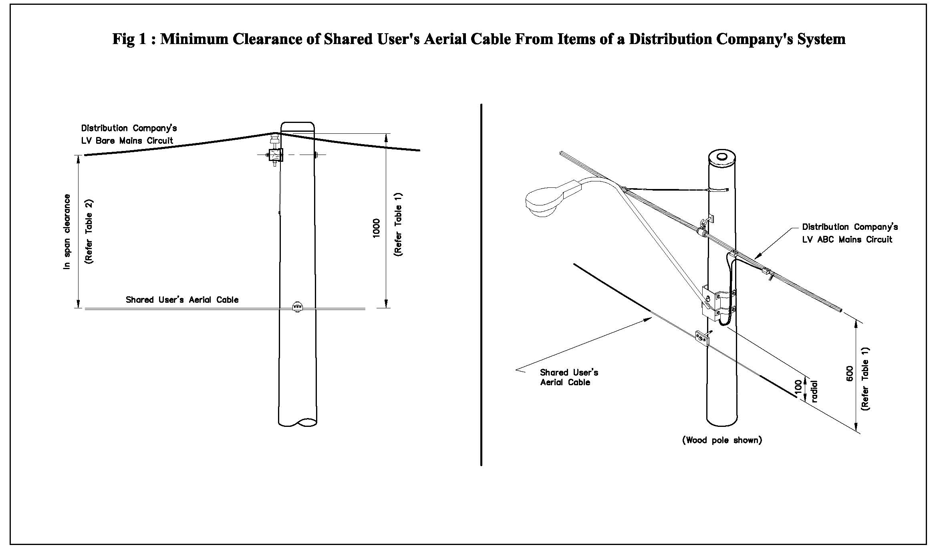
Figure 1-Minimum Clearance of Shared User's aerial cable from items of a distribution company's electrical system

Figure 2 - Minimum Clearance of Shared User's aerial cable from items of a distribution company's electrical system

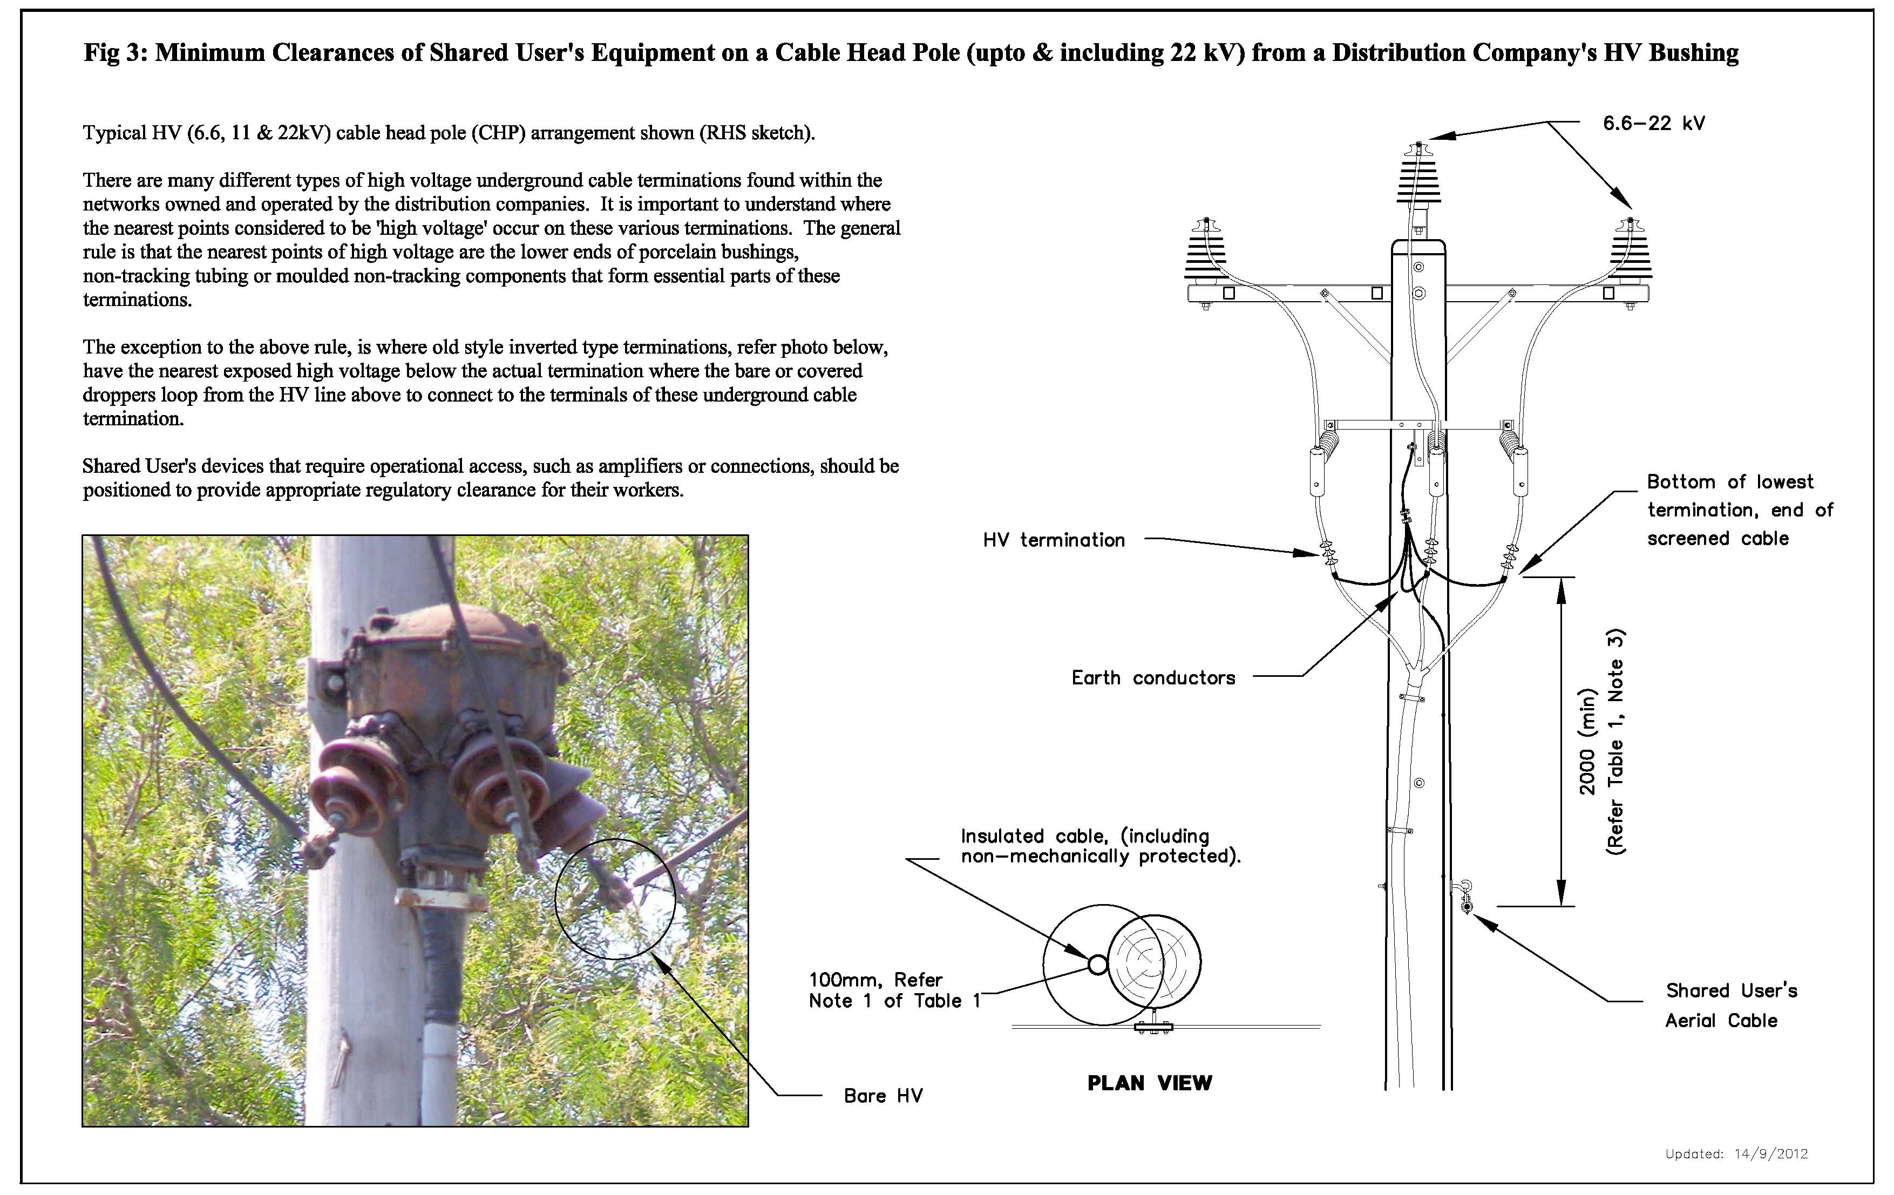
Figure 3 – Minimum Clearance of Shared User’s equipment on a cable head pole (cable termination pole)(up to& including 22kV) from a distribution companies HV Bushing
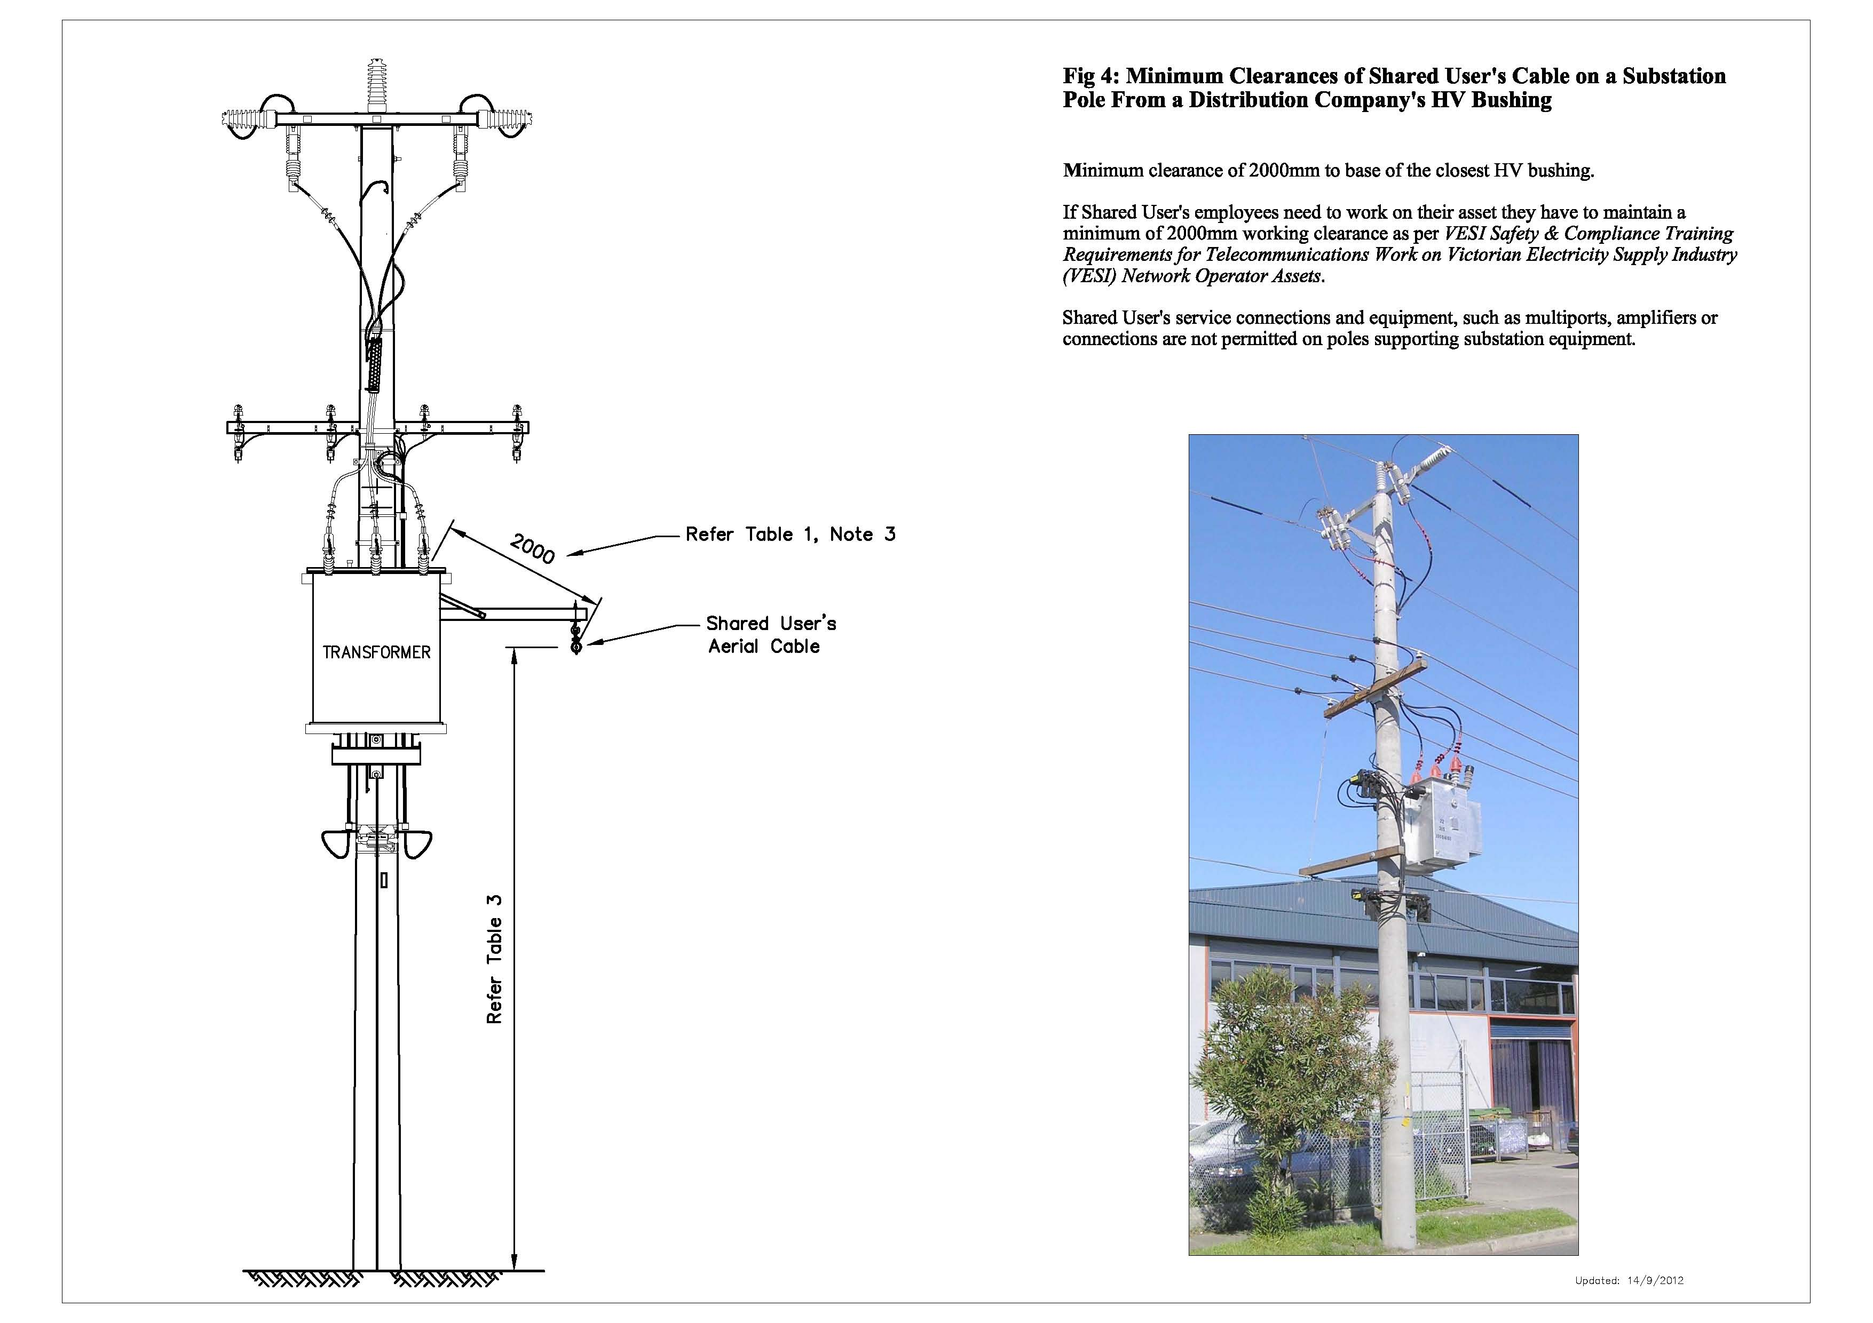
Figure 4 - Minimum Clearance of Shared User’s equipment on a Substation Pole from a distribution companies HV Bushing

Radio Frequency Telephone Equipment (Antennae)

Shared Users Equipment – Communication Antennae and Associated Equipment

An industry group involving Distribution Companies and mobile carriers has reviewed the inclusion of this type of equipment under this Code.

RF Related Application Forms (Preliminary/Formal Applications)

Preliminary Application Form

The Shared User must submit to the relevant Distribution Company a Preliminary Application form (or other form as required by the Distribution Company), listed in AppendixB1. In preparation of the form the Shared User must consider all requirements within this Code.
Approval of any Preliminary Application Form is not deemed as final approval for installation of Shared Use equipment.

Formal Application

Following the approval of the Preliminary Application, the Shared User must submit a Formal Application for assessment to the Distribution Company. Copy of the Formal Application form listed in Appendix B2. Formal Application must be in accordance with Clause 9.2 of this Code.

Pole Suitability

Attachment of Telecommunication Carrier - Macrocell Facilities (Tuft/Panel Antennae)

All shared user equipment defined as a Macrocell Facility is to be located above the Distribution Company’s electrical assets.

Poles with high voltage or bare low voltage electrical assets are considered unsuitable for Macrocell Facility installations. Below is a summary of which electrical assets can or cannot be located on a Pole hosting a Macrocell.
- Distribution Company Electrical Assets which can remain or exist on Poles hosting a Macrocell Facility
  - Public Light (bracket and luminaries)
  - Low voltage insulated overhead service line
  - Low Voltage aerial bundled cable (LV ABC)

- Distribution Company Electrical Assets which cannot remain or exist on Poles hosting a Macrocell Facility
  - High voltage assets of any kind;
  - Low voltage open wire (bare);
  - Low voltage cable head pole (cable termination pole);
  - Fused switch disconnector box;
  - Substation pole;
  - Frangible or slip based pole;
  - Hinged pole;
  - Capacitor bank pole;
  - Pole carrying any third party attachment (such as fibre optic cable, decorations, cable TV etc.).

Attachment of Telecommunication Carrier Microcell Facilities (Omni Antennae)

Below is a summary of which electrical assets can/cannot remain or exist on a Pole hosting a Microcell facility.

- Distribution Company Electrical Assets which can remain or exist on poles hosting a Microcell facility below the electrical assets
  - High voltage cables;
  - Low voltage open bare wire;
  - Public light (bracket and luminaries);
  - Low voltage insulated overhead service;
  - Low voltage Aerial Bundled Cable (LV ABC);

- Distribution Company Electrical Assets which cannot remain or exist on poles hosting a Microcell facility below the electrical assets;
  - High voltage cable head poles (cable termination poles);
  - Low voltage cable head poles (cable termination poles);
  - Fused switch disconnector box;
  - Substation pole;
  - Frangible or slip based pole;
  - Hinged pole;
  - Capacitor bank pole;
  - Pole carrying any third party attachment (such as fibre optic cable, decorations, cable TV etc.).

Tables

Table 4below sets out the minimum clearances that apply for the Shared User's Equipment relevant to this section of the Code.

Table 4 - Asset Clearances on Pole from Shared User’s Equipment to Distribution Company’s Assets
Shared User's Equipment |  | Item of Electricity Distribution System
 |  | Insulated LV Wiring (including insulated LV services) & UG Cable dressed on the pole | Earth & Supervisory O/H Circuits | LV Bare Mains & Services  O/H Circuit | FSD | FOLCB | LV ABC Mains  O/H Circuit | 6.6, 11, 22 kV O/H Circuits | 66 kV  O/H Circuit
(a) | RF Antenna is below (Excluding Macrocells) | 100 | 380 | 1000 | 1000 | 1000 | 600 | 2400 | 3900
(b) | RF Antenna is Above | 100 | Not Allowed | Not  Allowed | Not Allowed | Not Allowed | Not Allowed | Not Allowed | Not Allowed

Training Requirements for Access to Distribution Poles

The minimum training requirement for all personnel accessing Distribution Businesses poles on behalf of the mobile Carriers with regard to the attachment and maintenance of mobile telephone equipment is the five day Power Awareness Course as referenced in the
Safety & Compliance Training Requirements for Telecommunications Work on Victorian Electricity Supply Industry (VESI) Network Operator Assets (refer to www.vesi.com.au)

Mobile carriers must be able to demonstrate competence of all workers accessing distribution business poles.

Radio Frequency Isolation Requirements

Unless otherwise agreed between the Parties, the Shared User must ensure that the shared User’s RF Equipment located on a Pole can be isolated on site by Distribution Company staff.

All Isolation Switch designs will be required to be assessed and approved by the Distribution Businesses and must meet the requirements to be set out in the “VESI RF Isolation Statement for Third Party RF Devices Attached to Victorian Electricity Supply Industry Distributor’s Assets.

For the avoidance of doubt, the Shared User must comply with the “Distribution Companies Radio Frequency Isolation Statement of Requirements for Third Party Radio Frequency Devices attached to Distribution Companies Assets” as shown in Appendix B3.

The Shared User is required to have documentation on site that provides relevant details and instructions to the relevant distribution business before proceeding with a power shutdown to a telecommunications facility. The following information will be on site:

- Signage;
- National Site Archive (NSA) reference number;
- Carrier Site ID number;
- Carrier Network Operations Centre phone number;
- Isolation procedures (located in Isolation Cabinet where possible).

Isolation Processes and Documentation

The parties have agreed that where an isolation switch has been installed at a Radio Frequency site mounted on an electricity distribution pole, the mobile carrier must ensure that Isolation Procedure Documentation is available in the metering cabinet on site, except for locations where there are no meter boxes. This must include all relevant details including:

- Carriers network operations centre phone number;
- Use of the test device where required;
- Any other information which may be required.

Where an Isolation Switch has not been installed

An interim procedure for isolating mobile telephone telecommunication equipment is required during the initial roll out phase of the installation of Isolation Switches. During this interim phase, the Carriers have agreed that they will attend to each mobile telephone telecommunication equipment mounted on an electricity distribution pole on call within 4 hours of receiving a request from a Distribution Business to attend and isolate the Facility. The Carriers have agreed that in emergency situations they will attend to each site as a priority. The Distribution Businesses will provide reasonable notice of isolation requirements for planned works.

It is important that requests to Carrier Service Centres for on site isolation of RF devices clearly communicate the OH&S requirements.

Signage Requirements

Unless otherwise agreed between parties, the Shared User must ensure that the Shared User’s equipment located on a Pole is supported by appropriate signage. Signage for RF emitting devices is required to comply with the “Signage Requirements” shown below in clause 14.2.12 RF Signage Requirements.

Signage at all new mobile telephone telecommunications facilities approved by the Distribution Business under an application must comply with the Signage Requirements immediately after construction.

Update and Use of the National Site Archive

The mobile carriers have agreed that all mobile telephone telecommunication facilities will be entered into the National Site Archive (“NSA”).

Distribution Business pole owner and pole numbers are essential and best endeavours will be used to include mobile carrier Site Names and Site Reference Number and GPS coordinates.

Construction Notification

A mobile telephone telecommunication facility Construction Notification Form must be completed by the Carrier and returned to the relevant Distribution Business notifying of the construction completion.

The Construction Notification Form is provided in the Appendix B4.

RF Signage Requirements

Agreed signage requirements for shared use Electricity Distribution Poles with Telecommunications antennas.

Poles are to display the following signs:

Standard Sign 1 – Antenna Warning Isolation Procedure

Purpose | Advise of antenna in place and Isolation procedure
Attachment | Metal strap or screws (wooden pole only)
Mounted | Not more than 4.0 m from ground
Minimum Size | 50 x 170mm or 40 x 136mm where appropriate
Requirement | Two signs where required, approach and departure side

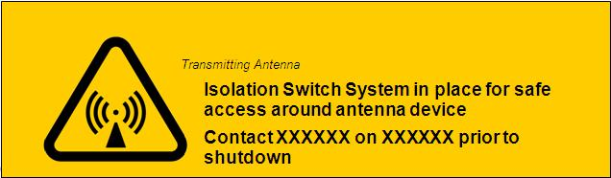
Figure 5-Standard Sign 1

Standard Sign 2 – RF Hazard Proximity

Purpose | To advise of RF Hazard in close proximity
Attachment | Metal strap or screws (wooden pole only)
Mounted | On pole min 2m below antennas
Minimum Size | 50 x 170mm or 40 x 136mm where appropriate
Requirement | Two signs where required, approach and departure side of pole

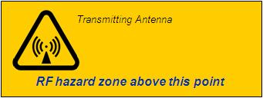
Figure 6-Standard Sign 2 Macro Antenna
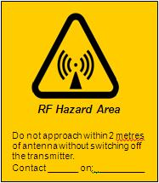
Figure 7-Standard Sign 2 Micro Cell Antenna

Standard Sign 3 – Site Identification on Poles

Purpose | To clearly Identify Carrier and Site ID
Attachment | Fixing to concrete and steel must be by metal band. Concrete and Steel poles must not be drilled. Timber poles may be drilled for attachment via screws.
Mounted | Not more than 4.0 m from ground
Minimum Size | 80mm x 120mm
Requirement | Where more than one carrier co-located on pole each carrier must provide a sign. Signs must be mounted side by side so that both can be seen simultaneously.

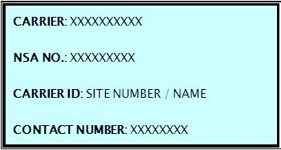
Figure 8-Standard Sign 3

Standard Sign 4 – Site Identification on Control Cabinet

Purpose | To clearly Identify Carrier and Site ID
Attachment | Fixing to concrete and steel must be by metal band. Concrete and Steel poles must not be drilled. Timber poles may be drilled for attachment via screws.
Mounted | At ground on the cabinet
Minimum Size | 80mm x 120mm
Requirement | Where more than one carrier co-located on pole each carrier must provide a sign. Signs must be mounted side by side so that both can be seen simultaneously.

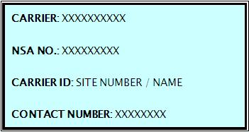
Figure 9-Standard Sign 4

RF Signage Requirements for Attachment to Poles

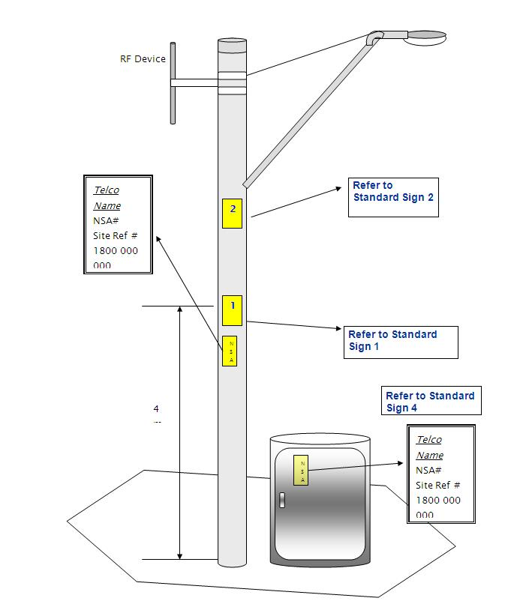
Figure 10-Signage Placement

Signs and Other Minor Attachments on Poles

Scope

The following sections of the Code set out the minimum requirements which apply to the attachment by a Shared User of its signs and other minor attachments to a Distribution Company’s power or public lighting poles. In setting out these requirements the Code provides support to any Agreement established between a Distribution Company and a Shared User.

The Shared User must not install or perform any works on a Distribution Company pole unless it has entered into a Facilities Access Agreement with the Distribution Company to permit installation of an Attachment.

Technical Conditions and Requirements

Unless otherwise approved by the Distribution Company the Shared User must ensure that the Attachment:

- Is not installed on the following pole types;
  - Substation poles;
  - High voltage cable head poles (cable termination poles);
  - Hinged poles;
  - Fuse switch disconnector (FSD) box poles, unless FSD is mounted within 1 metre of the crossarm; and
  - Unserviceable poles;
- Does not interfere with or impair the use of the Distribution Company or third party access, use, function or operation of any pole or equipment;
- Will only be affixed by using methods of attachments approved by the Distribution Company;
- Is attached within the Attachment Zone as described in the diagram below:

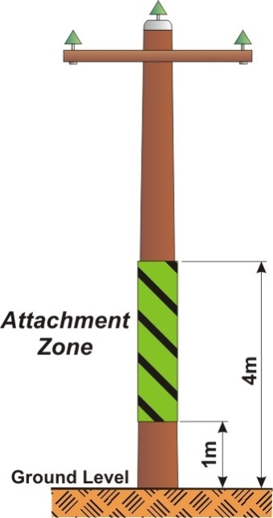
Figure 11 - Allowable Attachment Zone

- Where installed outside the Attachment Zone, as described in clause 14.3.2.d, any installation work is only undertaken with the approval of the Distribution Company. In such cases a request must be made in writing to the Distribution Company in order for the Distribution Company to consider the matter on a case by case basis;
- At all times where the Attachment projects over the roadway, it shall be placed so that its lower edge meets the following clearances:
  - 4.6m above the roadway for Local Traffic areas;
  - 4.9m above the roadway for Secondary Roads and Collector roads; and
  - 5.5m above the roadway for Primary Roads, Highways, Freeways and Tollways;
- Notwithstanding clause 14.3.2.f, if placed so as to project beyond the diameter of the pole the Attachment shall be placed so that its lower edge must not be less than 2.7m above the ground surface;
- Shall be securely fixed and be of such construction that under high wind conditions they cannot encroach within the limit specified above;
- Shall not exceed a total of 5 street sign Attachments to any one pole including all third party Attachments unless specifically approved by the Distribution Company;
- Is safe and does not contain any sharp points, edges or burrs that could cause injury to a person or the perforation of any rubber insulation gloves that an employee of the Distribution Company or any contractor engaged by the Distribution Company may be required to wear when working on the Distribution Company poles;
- Does not create any risk to the safety of any persons as far as reasonably practicable;
- Shall be constructed and erected in such a way that they can be removed by the Distribution Company when the Distribution Company determines that the removal of the Attachment is required;
- Shall be permanently labelled to identify the Shared User as the owner of the Attachment;
- Works to be undertaken are only performed by trained persons who have been given clear written directions by the Shared User to perform the works; and
- Shall not readily enable persons to climb the pole.

Existing Attachments

Where at the commencement date of a Facilities Access Agreement, any existing Attachments to the Distribution Company’s poles do not comply with the Technical Conditions and Requirements set out in clause 14.3.2, the Shared User agrees that:

- During its ordinary course of maintenance, it will at its own expense take all necessary steps to ensure that the existing Attachment comply with the Technical Conditions and Requirements. For the avoidance of doubt, the Shared User agrees that when it performs any works to an existing Attachment it will ensure that the Attachment and all their other Attachments affixed to that particular Distribution Company’s pole adhere to the Technical Conditions and Requirements;
- If it becomes aware of an existing Attachment which does not comply with the Technical Conditions and Requirements and which the Shared User considers is inaccessible to the Shared User due to electrical clearance requirements it will promptly contact the Distribution Company and the Distribution Company will at the cost of the Shared User arrange for the removal of the Attachment;
- If the Distribution Company identifies an existing Attachment which it considers does not comply with the Technical Conditions or Requirements, and poses an unacceptable risk to the health and safety of persons or interferes with the use, access, operation and function of the Distribution Company pole then the Distribution Company may direct the Shared User at the Shared User’s cost to immediately take all necessary steps to remedy the situation; and
- It will undertake a works program to ensure as a minimum all existing Attachments are removed from all Distribution Company pole types excluded from use under clause 14.3.2.a of the Technical Conditions and Requirements. The Shared User agrees to complete this works program within 5 years from the commencement date of the Facilities Access Agreement.

Recording of Attachments

Unless otherwise approved by the Distribution Company the Shared User must ensure that:

- Any Attachments including new and amendments to existing Attachments shall be recorded by the Shared User and include details such as the nature of the Attachment, location, the Distribution Company unique pole identification number and where available details as to the owner of the pole;
- The Attachments list is available to the Distribution Company upon request.

Auditing

The Shared User agrees that:

- It will undertake annual quality control audits of all works procedures and practices associated with the Attachment;
- It will report its auditing results in clause 14.3.5.a, at no cost to the Distribution Company, upon request;
- The Distribution Company may from time to time undertake an audit to check compliance with the requirements of this Code. In the event the Distribution Company finds there is a material breach of requirements, the Distribution Company may require the Shared User to undertake a full independent audit, at the Shared Users cost, and provide a copy of the audit report to the Distribution Company;
- Any reasonable cost incurred by the Distribution Company, in undertaking audits under this clause may be passed on to the Shared User.

Training Requirements

The Shared User must ensure that any works undertaken on the Distribution Company’s pole is carried out by persons who have received training and the person must be assessed by an RTO as competent. The training material must be developed by a Registered Training Organisation (RTO) and approved by the Distribution Company. The training material must as a minimum enable a person to;

- Have an adequate level of awareness of electrical safety;
- Identify applicable types of Distribution Company’s poles as per Clause 14.3.3a;
- Identify the difference between high voltage and low voltage distribution equipment on Distribution Company’s poles;
- Identify the difference between electricity cables, catenary and communication cables;
- Identify the difference between insulated and bare aerial lines or cables on Distribution Company poles;
- Know and understand all relevant clearance requirements to Distribution Company electrical equipment including both persons and plant;
- Know and understand all relevant personal protective equipment requirements including but not limited to natural fibre clothing with wrist to ankle cover, fully enclosed footwear and protective headwear and safety requirements including safety requirements for working at heights;
- Know and can perform appropriate first aid procedures including first aid procedures for burns and electric shock;
- Know and can perform all appropriate procedures (including visual assessment procedures) for ensuring that a Distribution Company pole is safe in all respects before commencing any work in relation to that Distribution Company’s pole.

The Shared User must also ensure that any works undertaken on the Distribution Company’s pole is carried out by persons who have been subject to ongoing assessment of their competency in regard to the above minimum competency requirements. They shall be competency assessed at no more than 3-yearly intervals and, where appropriate, training given to restore competency.

To effectively demonstrate ongoing competency of such persons the Shared User must maintain a record of all person’s competency assessments which are to be made available to the Distribution Company upon request.

Personal Electrical Clearance Requirements

The Shared User must ensure that any works undertaken on the Distribution Company’s pole is carried out by persons who maintain personal electrical clearances by only undertaking work within the Working Zone as described in the below diagram.

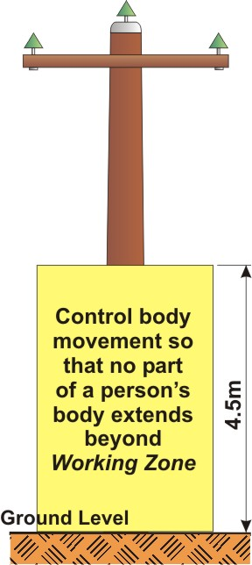
Figure 12-Personal Electrical Clearance Requirements
Notwithstanding the Working Zone indicated above, the Shared User must ensure that when work is performed within this zone, or where individual approval may have been granted to attach above the Attachment Zone (Refer to Clause 14.3.2.e), the Shared User must ensure that any attachment on the Distribution Company’s pole is carried out by persons who maintain the personal electrical clearances as outlined in the Electricity Safety (Installations) Regulations 2009.

Installation and Maintenance Requirements

Unless otherwise approved by the Distribution Company the Shared User must ensure that when maintaining, installing, removing, replacing, or repairing new or existing Attachments it:

- Must use only ladders or access platforms of a type recognised as suitable for work near electrical assets, and any access platform used must be accompanied by a current electrical test certificate;
- Will have in place safe work procedures which will as a minimum requirement
  - Specifically relate to the tasks being undertaken;
  - Be clearly readable and available on site at all times.
- Will regularly inspect the Attachments and maintain them in good condition;
- Will securely plug any hole on the Distribution Company’s timber pole created by the removal or adjustment of an Attachment using a method approved by the Distribution Company.

Note: A Safe to Climb test must be carried out prior to climbing each pole.

Tables

Table 5 - Minimum Clearances at or in Close Proximity to Pole for Shared User’s Aerial Equipment from Items of a Distribution Company’s System

Shared User's Equipment | Item of Electricity Distribution System
 | Distribution Communications Cables | Insulated LV Wiring (including insulated LV services) & UG Cable dressed on the pole | Earth & Supervisory O/H Circuits | Bare LV Mains & Services  O/H Circuit | FSD  Figure (2) | FOLCB  Figure (2) | LV ABC Mains  O/H Circuit | 6.6, 11, 22 kV O/H Circuits  Note (6) | 66 kV  O/H Circuit  Note (6)
Traffic light equipment, security lighting equipment, surveillance equipment, signs etc. | 300 | 100 | 380 | 1000 | 1000 | 1000 | 600 | 2400 | 3900

The following notes are to be read in conjunction with Table 1:

(1) Minimum clearance between Shared User’s Equipment and Distribution Company’s equipment such as public lighting brackets, earthing conductors, insulated LV wiring, insulated LV boxes etc. to provide a reasonable working clearance and prevent abrasion damage, is 100mm (Refer Fig. 1).

(2) a) Where exposed blade type LV isolators or fuses are present refer to the relevant Distribution Company for insulating measures of these devices before access. Otherwise a clearance of1400mm from bare LV mains is required.
b) For any Shared User equipment dressing past an FSD refer to the relevant Distribution Company for insulating measures of these devices. Refer to figure 2.
In all cases adequate clearances must be provided to ensure that the Distribution Company’s and Shared User’s Equipment can be safely maintained and operated. These devises are typically operated from ground level using an insulated stick and require unobstructed access from below.

(3) Where Shared User's Equipment is attached to a cable head pole (cable termination pole), or a wooden crossarm/insulated support fitted to a substation Pole, a clearance of 2000 mm (in accordance with the requirements in Clause9.6 of this document) shall be maintained from the nearest part of any HV bushing as shown in Figures 3 or 4 as applicable.

(4) When an underground cable is present on a pole, no item of Shared User’s Equipment shall be attached to the pole within the clearance distance stated. The Shared Users equipment must not cross the existing cable (Refer Figs. 2 and 3). The Shared User must not move or in any way adjust the cable to allow attachment of the Shared User’s Equipment.

(5) The above table clearances apply to pole structures without HV equipment such as isolators, fuses, switches etc. Where such equipment exists, additional clearances will be required. Refer to relevant Distribution Company for clearance requirements.

(6) These minimum clearances include provision for future subsidiary circuits. However alternative clearances may be applicable. Refer to relevant Distribution Company for clearance requirements.

(7) Any attachment to the pole (excluding cables and conduits dressed to the pole) must not be lower than 2700mm from the ground level.

(8) Minimum Clearance between telecommunications cables attached to the pole shall be in accordance with ACIF C524:2013 – External Telecommunication Cable Networks (300mm between cables).

(9) Minimum Clearance between telecommunications cables dressed on the pole or aerial customer leads attached to the pole shall be in accordance with ACIF C524:2013 – External Telecommunication Cable Networks(50mm between insulated cables and 100mm between non-insulated cables).

Right to Remove Attachments for Works

Where:
- The Distributor wishes to carry out maintenance work on the Distributor’s Poles or replace or move the Distributor’s Poles; or
- The Distributor considers there is an emergency effecting health or safety; or
- The Attachment is affecting the operation or maintenance of the Distributor’s assets;

Then the distributor may:

- Detach or relocate the Attachment without giving prior notice to the Shared User; or
- Detach the Attachment and notify the Shared User. In circumstances where the Attachment is not damaged during detachment or removal, the sign shall be retained for the Shared User at an agreed location for a period of 5 business days. The distributor will not be held liable for any costs associated with damaged sign during removal or detachment; or
- By written request, require the Shared User to detach and/or relocate the Attachment within 5 business days at no cost to the Distributor.

Flags, Banners and other Decorations (or Higher Up) Attachments on Poles

Scope

The following sections of the Code set out the minimum requirements which apply to the attachment by a Shared User of its Flags, Banners or other Decorations to a Distribution Company’s power or public lighting poles. In setting out these requirements the Code provides support to any Agreement established between a Distribution Company and a Shared User.

The Shared User must not install or perform any works on a Distribution Company pole unless it has entered into a Facilities Access Agreement with the Distribution Company to permit installation of an Attachment.

Applications to install Attachments for promotional purposes must be lodged with the Distribution Company in accordance with clause 14.4.2 below.

Applications

The Shared User is required to submit a written application to apply for the installation of Attachments on the Distribution Company’s poles. Unless otherwise agreed by the Distribution Company, the application must include as a minimum:

- Location and pole number of the Distribution Company’s poles which the Shared User wishes to apply for shared use;
- Preferred mounting height of the Attachment for each pole;
- Detailed dimensioned drawings of the Attachment the Shared User proposes to attach to the Distribution Company’s poles;
- Details as to the proposed method/s to be used for fixing the Attachment to the Distribution Company’s poles;
- Period of attachment including proposed installation and removal dates;
- A completed assessment from a suitably qualified person approved by the Distribution Company certifying:
  - The suitability of the Attachment (including the attachment method);
  - The suitability of the Distribution Company’s pole for shared use; and
  - That the Attachment will not interfere with or impair any Distribution Company or third party equipment;
- Details as to the wording and/or artwork to be displayed on the Attachment;
- Details as to the proposed installation and maintenance contractor including training and competency;
- Details as to the proposed inspection and maintenance program to be undertaken; and
- Any such other particulars as may be requested by the Distribution Company.

Technical Conditions and Requirements

Unless otherwise approved by the Distribution Company the Shared User must ensure that the Attachment:

- Is not installed on the following pole types;
  - Substation poles;
  - Hinged poles;
  - All types of frangible poles;
  - High voltage cable head poles (cable termination poles);
  - High voltage switch poles;
  - Fuse switch disconnector (FSD) box poles, unless FSD is mounted within 1 metre of the crossarm;
  - Capacitor bank poles; and
  - Unserviceable poles;
- Does not interfere with or impair the use of the Distribution Company’s or third parties access, use, function or operation of any pole or equipment;
- Will only be affixed by using a methods of attachment approved by the Distribution Company;
- Must be below the lowest Aerial Cable and meet the following electrical safety clearance requirements so that the highest point of any Attachment shall not be closer than:
  - 4.5m to the nearest bare 66kv conductor;
  - 3.0m to the nearest bare 22kV, 11kV or 6.6kV conductor;
  - 2.0m to the nearest HV Aerial Bundled Cable (22kV);
  - 1.8m to the nearest bare LV conductor;
  - 1.4m to the nearest LV Aerial Bundled Cable; and
  - 1.2m to the nearest Aerial earth or independently earthed catenary cable;
- If placed so as to project over the roadway or in a position where the Attachment could be struck by a vehicle the Attachment shall be placed so that its lower edge meets the following minimum clearances:
  - 4.6m above the roadway for Local Traffic areas;
  - 4.9m above the roadway for Secondary Roads and Collector roads; and
  - 5.5m above the roadway for Primary Roads, Freeways and Tollways;
- If placed so as to project over pedestrian areas the Attachment shall be placed so that its lower edge must not be less than 2.7m above the ground surface;\
- Shall be securely fixed and be of such construction that under high wind conditions it is unlikely to encroach within the limits specified above;
- Will not be strung between Distribution Company poles or to other structures;
- Is safe and does not contain any sharp points, edges or burrs that could cause injury to a person or the perforation of any rubber insulation gloves that an employee of the Distribution Company or any contractor engaged by the Distribution Company may be required to wear when working on the Distribution Company’s poles;
- Does not create any risk to the safety of any persons as far reasonably practicable;
- Shall be constructed and erected in such a way that they can be removed by the Distribution Company when the Distribution Company determines that the removal of the Attachment is required;
- Shall be permanently labelled to identify the Shared User as the owner of the Attachment;
- Works to be undertaken are only performed by trained persons who have been given clear written directions by the Shared User to perform the works; and
- Shall not readily enable persons to climb the pole.

Record Keeping

Unless otherwise approved by the Distribution Company the Shared User must ensure that it will maintain records of:

- Its current Attachment locations and details; and
- Attachment inspections and maintenance undertaken;

And provide these records to the Distribution Company on request.

Auditing

That Shared User agrees that;

- It will undertake annual quality control audits of all works procedures and practices associated with the Attachments;
- It will report its auditing results in clause 14.4.5.a, at no cost to the Distribution Company on request;
- The Distribution Company may from time to time undertake an audit to check compliance with the requirements of this Code. In the event the Distribution Company finds there is a material breach of requirements, the Distribution Company may require the Shared User to undertake a full independent audit, at the Shared Users cost, and provide a copy of the audit report to the Distribution Company; and
- Any reasonable cost incurred by the Distribution Company, in undertaking audits under this clause may be passed on to the Shared User.

Training Requirements

The Shared User must ensure that any works undertaken on the Distribution Company’s pole is carried out by persons who have received training and the person must be assessed by an RTO as competent. The training material must be developed by a Registered Training Organisation (RTO) and approved by the Distribution Company. The training material must as a minimum enable a person to;

- Have an adequate level of awareness of electrical safety;
- Identify applicable types of Distribution Company’s poles as per clause 14.4.3.a;
- Identify the difference between high voltage and low voltage distribution equipment on Distribution Company’s poles;
- Identify the difference between electricity cables, catenary and communication cables;
- Identify the difference between insulated and bare aerial lines or cables on Distribution Company poles;
- Know and understand all relevant clearance requirements to Distribution Company electrical equipment including both persons and plant;
- Know and understand all relevant personal protective equipment requirements including but not limited to natural fibre clothing with wrist to ankle cover, fully enclosed footwear and protective headwear and safety requirements including safety requirements for working at heights;
- Know and can perform appropriate first aid procedures including first aid procedures for burns and electric shock; and
- Know and can perform all appropriate procedures (including visual assessment procedures) for ensuring that a Distribution Company pole is safe in all respects before commencing any work in relation to that Distribution Company’s pole.

The Shared User must also ensure that any works undertaken on the Distribution Company’s pole is carried out by persons who have been subject to ongoing assessment of their competency in regard to the above minimum competency requirements. They shall be competency assessed at no more than 3-yearly intervals and, where appropriate, training given to restore competency.

To effectively demonstrate ongoing competency of such persons the Shared User must maintain a record of all person’s competency assessments which are to be made available to the Distribution Company upon request.

Personal Electrical Clearance Requirements

The Shared User must ensure that any attachment on the Distribution Company’s pole is carried out by persons who maintain the personal electrical clearances as outlined in the Electricity Safety (Installations) Regulations 2009.

Installation and Maintenance Requirements

Unless otherwise approved by the Distribution Company the Shared User must ensure that when maintaining, installing, removing, replacing, or repairing new or existing Attachments it:

- Must use only an insulated access platform of a type recognised as suitable for work near live electrical assets, and this access platform must be accompanied by a current electrical test certificate;
- Will have in place safe work procedures which will as a minimum requirement:
  - Specifically relate to the tasks being undertaken; and
  - Be clearly readable and available on site at all times;
- Will regularly inspect the Attachments and maintain them in good condition; and
- Will securely plug any hole on the Distribution Company’s timber pole created by the removal or adjustment of an Attachment using a method approved by the Distribution Company.

Right to Remove Attachments for Works

Where:

- The Distributor wishes to carry out maintenance work on the Distributor’s Poles or replace or move the Distributor’s Poles; or
- The Distributor considers there is an emergency effecting health or safety; or
- The Attachment is affecting the operation or maintenance of the Distributor’s assets;

Then the distributor may:

- Detach or relocate the Attachment without giving prior notice to the Shared User; or
- Detach the Attachment and notify the Shared User. In circumstances where the Attachment is not damaged during detachment or removal, the Attachment shall be retained for the Shared User at an agreed location for a period of 5 business days. The distributor will not be held liable for any costs associated with damaged sign during removal or detachment; or
- By written request, require the Shared User to detach and/or relocate the Attachment within 5 business days at no cost to the Distributor.

Distribution Business Boundaries

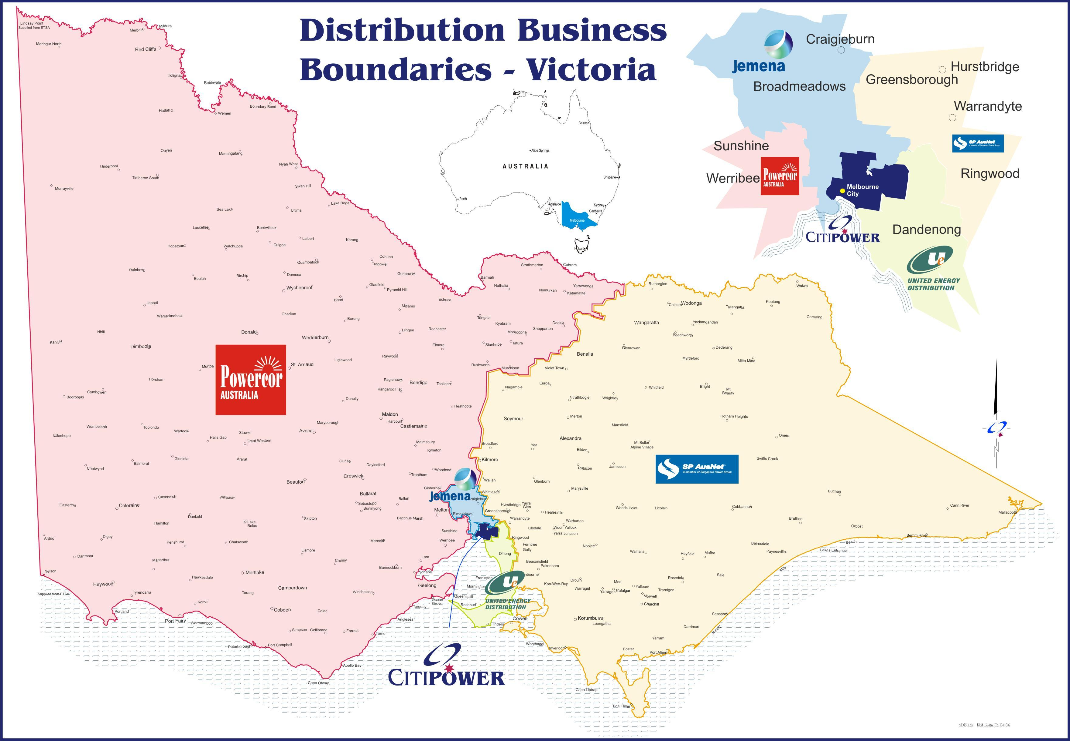
Figure 13-Distribution Business Boundaries

Distribution Business Fault and Emergency Contacts

CitiPower
131 280
www.powercor.com.au

SP AusNet
131 799
www.sp-ausnet.com.au

Powercor
132 412
www.powercor.com.au

Jemena Electricity Network
131 626
www.jemena.com.au

United Energy Distribution
132 099
www.ue.com.au

Appendices

Appendix A – Application for Shared Use of Pole
[Note: Copies of Application are available from the Distribution Company. Specimen copy only - Do Not Complete.]

Application No: xxxxxx
APPLICATION FOR SHARED USE OF POLE
(Read in conjunction with Code of Engineering
Practice for Shared Use of Poles)
PART 1 (Shared User to Complete)

SHARED USER DETAILS (Please Print)
1.1 Name...........................................................................................
1.2 Address........................................................................................
..........................................................................Postcode...................
1.3 Contact Person.........................................
1.4 Phone No .................... Fax No .................

POLE FOR WHICH SHARED USE IS REQUIRED
1.5 Pole ID No (clause 7.1) .........................
1.6 Property No .........................
1.7 Street/Road .........................
1.8 City/Suburb .........................
1.9 Postcode .........................

DETAILS OF SHARED USE
1.10 Date Required ..../...../......
1.11 Has Fly-Off Point only been used? (clause 6.6(b)) Yes No
1.12 Classification (clause 8.1) Normal Special
1.13 Category (clause 9.1) A B C D
1.14 Number of Fly-Off Points (clause 12.2(g)(i)) .......................
1.15 Number of Aerial Customer Leads (clause 12.2(g)(ii)).......................
1.16 Is Identification letter required? (clause 16(b)(i)) Yes No
1.17 Is 500 Metre Rule being applied? Yes No
(Refer Appendix F and G of Code)

ADDITIONAL INFORMATION
For the following items the Shared User shall indicate if additional information is provided or whether provision of this information is considered as not applicable (N/A).
1.18 Map (clause 7.3) Yes No N/A
1.19 Method of Attachment (clause 11.1(a)(i)) Yes No N/A
1.20 Equipment to be Attached (clause 11.1(a)(ii)) Yes No N/A
1.21 Cable/Conductor Type (clause 11.5(a)) Yes No N/A
1.22 Cable/Conductor Stringing (clause 11.5(c)) Yes No N/A
1.23 Earth Potential Rise mitigation (clause 11.6(b)(i)) Yes No N/A
1.24 Low Frequency Induction mitigation (clause 11.7(a)) Yes No N/A
1.25 Earthing System details (clause 11.8(a)) Yes No N/A
1.26 Make Ready Works (clause 12.4(c)(iii)) Yes No N/A
1.27 Calculation results (clause 12.4(c)(iii) Yes No N/A
1.28 Back-feeding details (clause 15.10(b)) Yes No N/A
1.29 Method of Attachment of identification letter Yes No N/A
(clause 16(b)(ii))

DECLARATION
1.24 I ........................................, an authorised officer of the Shared User, hereby certify that the information contained in this Application is true and correct and is not misleading or deceptive.
I hereby acknowledge that the Distribution Company will:
(a) use the information in this Application to:
(i) make appropriate decisions in relation to the Application; and
(ii) carry out its necessary investigations in relation to the Pole designs including whether the Make Ready Works are required;
(b) be relying upon this Application to make a number of decisions concerning the Application and Shared Use of Pole.

Signature of Shared User ........................................................ Date ..../..../....
Note: Process of Application
The following steps will occur in relation to an Application lodged by a Shared User.
1. The Distribution Company will, at cost of the Shared User, check the suitability of the Pole for Shared Use and will advise the Shared User of any Make Ready Works required.
2. Where no Make Ready works are specified in the Application and the Distribution Company accepts the Application then an invoice for the licence fee will be issued and, when paid, a licence to permit Shared Use of the Pole by the Shared Use will be issued.
3. Where Make Ready Works are required and the Application is accepted then the Make Ready Works will be carried out by the Distribution Company.
4. After the Make Ready Works have been completed, an invoice for Make Ready Works, the licence fee and any other fees will be issued to the Shared User. Upon payment a licence will be granted.

PART 2 (Distribution Company to complete)

APPLICATION PROCESSING (Please print)
2.1 Processing Officer .....................................................
2.2 Phone No ..................................... Fax No .....................................
2.3 Date Application Received ...../....../.......
2.4 Date Applicant notified:
(i) Application accepted ....../......../.......
(ii) Application rejected ....../......../.......
(iii) Make Ready Works costs ....../......../.......
(iv) Other applicable costs ....../......../.......
2.5 Date:
(i) Make Ready Works costs accepted by Applicant....../......../.......
(ii) Other applicable costs accepted by Applicant ....../......../.......
(iii) Make Ready Works commenced ....../......../.......
(iv) Make Ready Works completed ....../......../.......
(v) Make Ready Works invoice sent ....../......../.......
(vi) Other invoices sent ....../......../.......
(vii) All payment(s) received ....../......../.......
(viii) Licence issued ....../......../.......

Signature of Officer named in 2.1 ............................. Date ....../......./.......

Appendix B1 – Application Form Preliminary

INSTALLATION OF RADIO FREQUENCY TELECOMMUNICATIONS FACILITIES ON ELECTRICITY DISTRIBUTION POLES

PRELIMINARY POLE ASSESSMENT FORM

Date of this Preliminary Enquiry …….. / …….. / ……..

1. DETAILS OF PARTY MAKING ENQUIRY

Carrier:

Contact Person:

Company Name (of contact person if not the Carrier)

Address: (Business) P/Code:

Address: (Postal) P/Code:

Email: Phone No: Mobile:

2. CARRIER AUTHORISATION FOR THE APPLICATION

Contact Person:

Signature:

Company Name
Address: (Business) P/Code:

Address: (Postal) P/Code:

Email: Phone No: Mobile:

3. CONTACT FOR STRUCTURAL INFORMATION

Contact Person:

Company Name
Address: (Business) P/Code:

Address: (Postal) P/Code:

Email: Phone No: Mobile:

4. AGREEMENT/LICENCE UNDER WHICH ENQUIRY IS MADE

Name of Agreement/Licence:

Parties to the Agreement/Licence:

5. POLE FOR WHICH THE ENQUIRY IS MADE

Pole Number: Pole Type: (wood/concrete/steel/other)

Street/Road Name: Nearest House No:

Suburb: Postcode: Melways Ref:

* Please attach to this application a photo of the site

6. PROPOSED TELECOMMUNICATIONS FACILITY DETAILS

- Type of Facility: (Tuft/Panel/Omni/Other)

- Facility Classification: (Microcell/Macrocell/Other)

- Carrier Site Reference Number:

- Carrier Site Name:

ENQUIRY SUMMARY

We seek confirmation from the Distribution Company on the suitability of the above pole for shared use to install the following radio frequency telecommunications facility.

Our initial site inspection has indicated that the following make ready works will/may be required to be undertaken prior to the pole being suitable for use and that approval of the pole will be subject to a formal application.

(please indicate

Can you please provide a preliminary pole assessment approval based on the above information. Subject to this preliminary approval, a formal application will be submitted to you.

Signature: (Carrier) …………..…………….. Name: ………….………………

Office Use Only

(The Distribution Company) provides preliminary approval to (the Carrier) to proceed with a formal application for the above site. Please find attached the Pole Licence Application Form.

Signature: (Distribution Company) …………..… Name: ………….………………

Appendix B2 – Application Form Formal

INSTALLATION OF RADIO FREQUENCY TELECOMMUNICATIONS FACILITIES ON ELECTRICITY DISTRIBUTION POLES
Office Use

File No.
: _ _ _ _ _ __

Date Received:

//

POLE LICENCE APPLICATION FORM

Date of Preliminary Pole Assessment Approval …….. / …….. / ……..

Date of this Application …….. / …….. / ……..

Application Reference Documents
Applications should be read in conjunction with the:
- Relevant Carrier and Distribution Company Licence Agreement,
- Memorandum of Understanding (Carriers and Distribution Companies)
- Carriers and Distribution Companies agreed Operations Manual
- Code of Engineering Practice for Shared Use of Poles

1. APPLICANT DETAILS

Applicant: (Carrier)

Contact Person:

Company Name (of contact person if not the Carrier)

ABN:

Address: (Business) P/Code:

Address: (Postal) P/Code:

Email: Phone No: Mobile:

2. AGREEMENT/LICENCE UNDER WHICH APPLICANT IS APPLYING

Name of Agreement/Licence:

Parties to the Agreement/Licence:

3. POLE FOR WHICH LICENCE IS REQUIRED

Pole Number: Pole Type: (wood/concrete/steel/other)

Street/Road Name: Nearest House No:

Suburb: Postcode: Melways Ref:

4. PROPOSED TELECOMMUNICATIONS FACILITY DETAILS

- Type of Facility: (Tuft/Panel/Omni/Other)

- Facility Classification: (Microcell/Macrocell/Other)

- Carrier Site Reference Number:

- Carrier Site Name:

- Allocated National Site Archive Reference Number:

- Isolation Switch Make: Model No:

- Does this Isolation Switch make/model meet operations manual standard?
(Refer to VESI RF Isolation Statement for Third Party RF Devices Attached to VESI Distributor’s Assets)
YES / NO

- Has this isolation unit been approved by the distributor?: YES / NO
(if yes, provide copy of approval letter)

- Will the facility have battery back up? YES / NO

- Will signage meet operations manual requirements?
(Refer to ‘Shared Use Electricity Distribution Poles with
Telecommunication Antennas’) YES / NO

- Will the facility be metered?:
(If no, provide details of Amps and Power consumption of
the relevant facility) YES / NO

- Will use of the facility be shared with another existing carrier: YES / NO
(If yes, provide details)

5. DESIGN SUMMARY

- Are any Make Ready Works required? YES / NO
(If yes, provide summary below, including details
such as pole change overs, bundling or undergrounding
of electricity assets, etc.)

- Does the design comply with all clearances to electrical
assets set out in the Code of Engineering Practice? YES / NO
(provide technical drawings which specify the location of the RF equipment in relation to the electrical distribution assets)

- RF EME Drawings Submitted?
(provide detailed site specific information as to the emission of radiofrequency electromagnetic energy for each device, including exclusion zones for both occupational and non-occupational workers in accordance with the ARPANSA Radiation and Protection Standard
(Maximum Exposure Levels to Radiofrequency Fields 3kHz to 300GHz) YES / NO

- Has a structural assessment of the pole been conducted? YES / NO
(provide relevant certificate or calculations as required
by the distribution company)

6. Application Declaration

I as the undersigned applicant hereby certify that the information contained in this application complies to the best of my knowledge, with the application reference documents listed on this form and is true and correct and not misleading or deceptive in anyway.

Signature: (Carrier) …………..…………….. Name: ………….………………

Position Held: …………………………………….. Date: ..… /….. /….…

Appendix B3 – VESI RF Isolation Statement

VESI RF Isolation Statement
For
Third Party RF Devices attached to Victorian Electricity Supply Industry Distributor’s Assets.

Table of Contents
1 EXECUTIVE SUMMARY 55
1.1 THIRD PARTY RF EQUIPMENT 55
1.2 ISOLATION DEVICES 55
2 DEFINITIONS 55
3 PURPOSE / SCOPE 56
4 REQUIREMENTS 56
4.1 RF EQUIPMENT ISOLATORS. 56
4.2 BREAKING DEVICES THAT CANNOT BE LOCKED 56
4.3 RF ISOLATORS MOUNTED WITHIN THE OWNER’S EQUIPMENT 56
4.4 INDEPENDENT EARTHING SYSTEM. 56
4.5 COMPONENTS LOCATED ON THE ELECTRICAL DISTRIBUTION ASSET. 56
4.6 PROTECTION OF PUBLIC FROM ACCIDENTALLY MOVED RF EQUIPMENT 56
4.7 VARIATIONS 56

1 Executive Summary
1.1 Third Party RF Equipment

All sites where Third party RF equipment is attached to electricity distributor’s assets shall have a Radio Frequency (RF) isolator which is readily accessible to electrical distribution business workers.

1.2 Isolation Devices
All isolation devices shall meet the requirements specified in section 4 of this document.

2 Definitions
ARPANSA – Australian Radiation Protection and Nuclear Safety Agency

Breaking Device – means the actual component in the isolator circuit that opens when the Isolator is operated.

Control Circuit – The control circuit refers to any circuit that is used to control the operating state of the breaking device in the RF Signal Circuit.

Electricity Distributor Asset – Is any structure or piece of equipment owned by the Electricity Distributor.

Isolation – refers to the process of disconnecting the RF Equipment from any possible sources of RF signal by means which will prevent unintentional re-activation of the RF Equipment and which is assessed as a suitable step in the process of making safe for access purposes.

Isolator – means the device which when operated as part of the isolation process, will produce an open position, between all sources of RF signal and equipment mounted on Electricity distributor’s asset.

Removable Link – means a component such as a solid link or fuse that may be removed from the circuit while de-energised to prevent accidental re-energising.

RF Equipment –refers to any third party asset attached to an electricity distributor’s asset, which is able to emit radiofrequency fields in excess of exposure levels for the general public, as defined by ARPANSA standard “Maximum Exposure Levels to Radiofrequency Fields – 3kHz to 300 GHz” (RPS3).

RF Signal Circuit – The RF signal circuit refers to the circuit in which the signal travels to the RF Equipment from the third parties signal generation equipment.

Shall – is to be interpreted as “mandatory”

Third Party – Any party applying to install RF emitting equipment on VESI assets.

VESI – Victorian electricity supply industry

3 Purpose / Scope
The purpose of this document is to define the location of the electrical and mechanical switching apparatus used in the process for isolating third party RF devices attached to electricity distributors’ assets.
This requirements statement applies to all Third Party RF Equipment attached to the electrical distributor’s assets.

4 Requirements
All sites where RF equipment is attached to the electricity distributors’ assets shall have an RF Equipment isolator.

4.1 RF Equipment Isolators.
All RF Isolators shall have:
• Adequate signage to positively identify the RF Equipment to be isolated.
• Clear consistent RF isolation instruction documentation such that persons attending the site will have no difficulty in operating the device.
• One isolation point for all of the RF Equipment attached to the electricity distributor’s asset per carrier.
• A means of positive isolation. Methods of positive isolation include:
o Use of breaking device that can be locked, tagged or has a removable link such that the broken connection cannot be accidentally re-closed on the RF signal circuit. Locks, tags or removable links on a control circuit are not adequate for isolation.

4.2 Breaking Devices that Cannot be Locked
Breaking devices on the RF signal circuit that cannot be locked, tagged or removed may be used if a removable link between the breaking device and the RF Equipment is installed. The breaking device in this situation shall provide a method to identify when the circuit has opened, to prevent hazardous situations that may arise from removing energised links.

4.3 RF Isolators Mounted within the Owner’s Equipment
RF Isolators shall be mounted within the owner’s equipment and not to be located on the electrical distributor’s asset unless agreed to by the relevant electrical distribution business.

4.4 Independent Earthing System.
All electrical installations for RF sites shall have an earthing system that is independent to the electrical distributor’s earthing system.

4.5 Components Located on the Electrical Distribution Asset.
Components located on the electrical distribution asset shall not constitute an ‘Electrical Installation’ as defined in the Electricity Safety Act 1998.

4.6 Protection of public from accidentally moved RF Equipment
There is a preference for any site where any Third Party RF Equipment is installed that some means of isolating the RF Equipment immediately in the event of an accidental change in the location of the RF Equipment and thus avoid any potential hazard to the general public.

4.7 Variations
Variations to this requirements statement must be authorised by the operator of the electrical distributor’s asset.

Appendix B4 – Construction Notification Form

INSTALLATION OF RADIO FREQUENCY TELECOMMUNICATIONS FACILITIES ON ELECTRICITY DISTRIBUTION POLES
Office Use

File No.
: _ _ _ _ _ __

Date Received:

/ /

POST CONSTRUCTION DETAILS FORM

Date of submission …….. / …….. / ……..

Date of Pole Assessment Approval …….. / …….. / ……..

Date of Construction Completion …….. / …….. / ……..

1. APPLICANT DETAILS

Applicant: (Carrier)

Contact Person:

Company Name (of contact person if not the Carrier)

ABN:

Address: (Business) P/Code:

Address: (Postal) P/Code:

Email: Phone No: Mobile:

2. POLE DETAILS

Pole Number: Pole Type: (wood/concrete/steel/other)

Confirm final Pole Number on site is same as closeout documentation: YES / NO

Street/Road Name: Nearest House No:

Suburb: Postcode: Melways Ref:

3. INSTALLED FACILITY DETAILS

- Type of Facility: (Tuft/Panel/Omni/Other)

- Facility Classification: (Microcell/Macrocell/Other)

- Carrier Site Reference Number:

- Carrier Site Name:

- Allocated National Site Archive Reference Number:

- Isolation Switch Location: Pole / In ground cabinet / Meter box

- Does this Isolation Switch make/model meet operations manual standard?
(Refer to VESI RF Isolation Statement for Third Party RF Devices Attached to VESI Distributor’s Assets) YES / NO

4. CHECKLIST OF SITE COMPLETION DOCUMENTATION

1. As Built Drawings A3 2. Photos (inc. signage)

3. Isolation Switch Procedures 4. EME Compliance Materials

5. Other ………….

4. STATUS OF TENURE AGREEMENT DOCUMENTATION

Fees Paid: YES / NO

Site Agreement Executed: YES/NO

Comments:

5. CARRIER CONTACT DETAILS POST CONSTRUCTION

Carrier Contact for site payment issues:

Carrier Contact for ongoing operational issues:

6. Declaration

I as the undersigned applicant hereby certify that the information contained in this application complies to the best of my knowledge, with the application reference documents listed on this form and is true and correct and not misleading or deceptive in anyway.

Signature: (Carrier) …………..…………….. Name: ………….………………

Position Held: …………………………………….. Date: ..… /….. /….….

